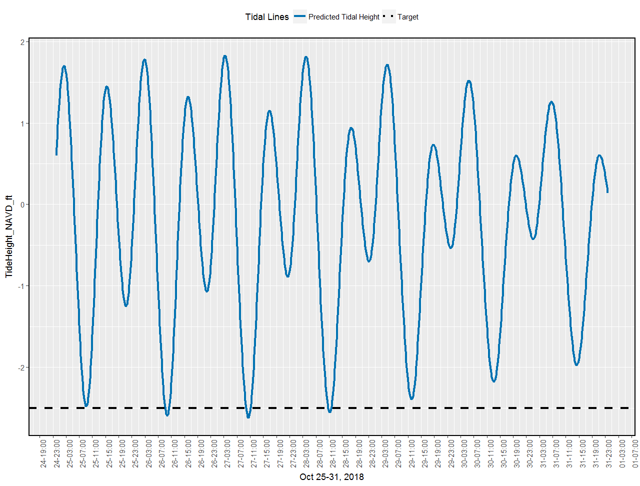

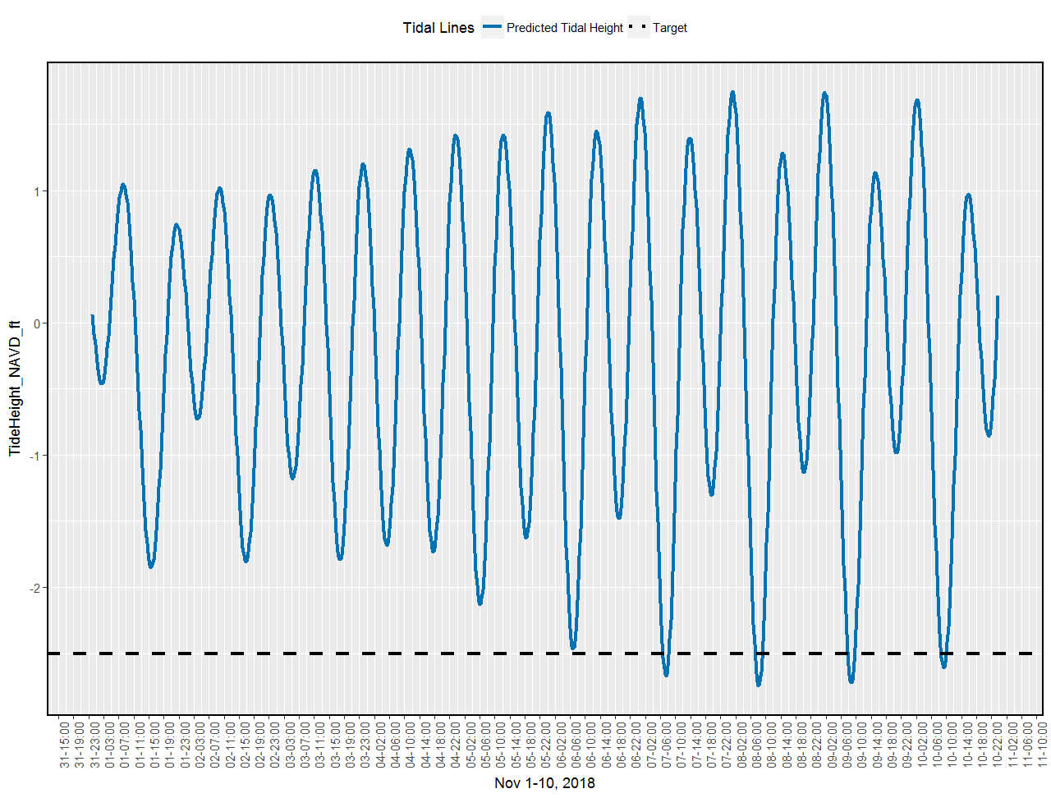

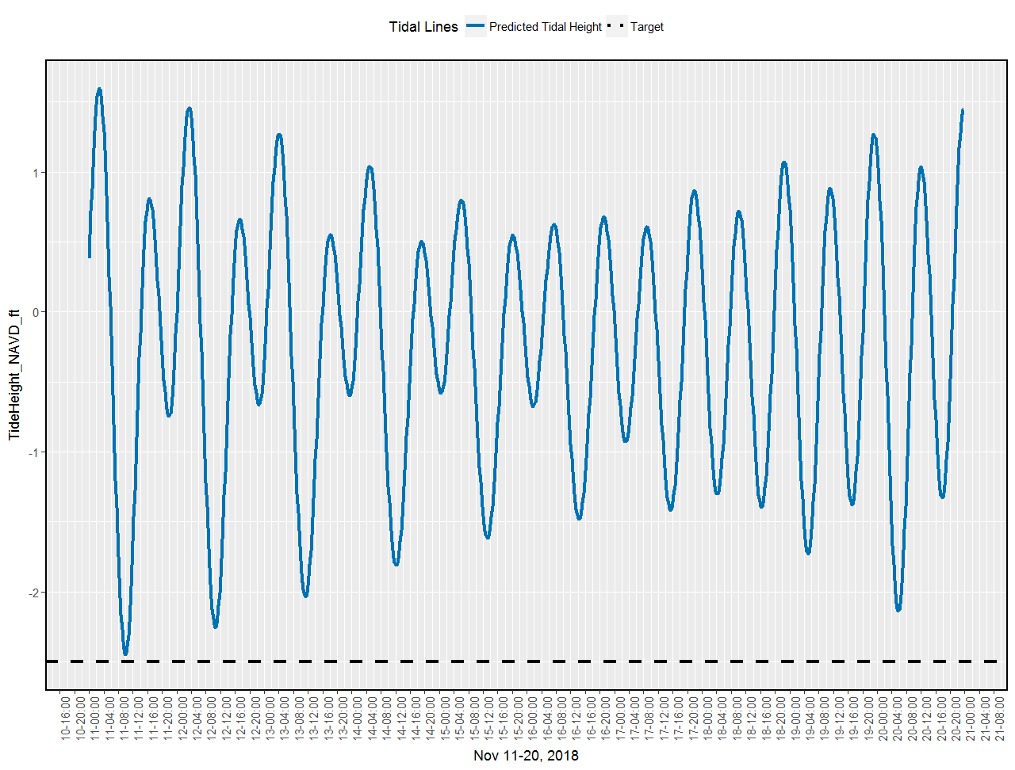

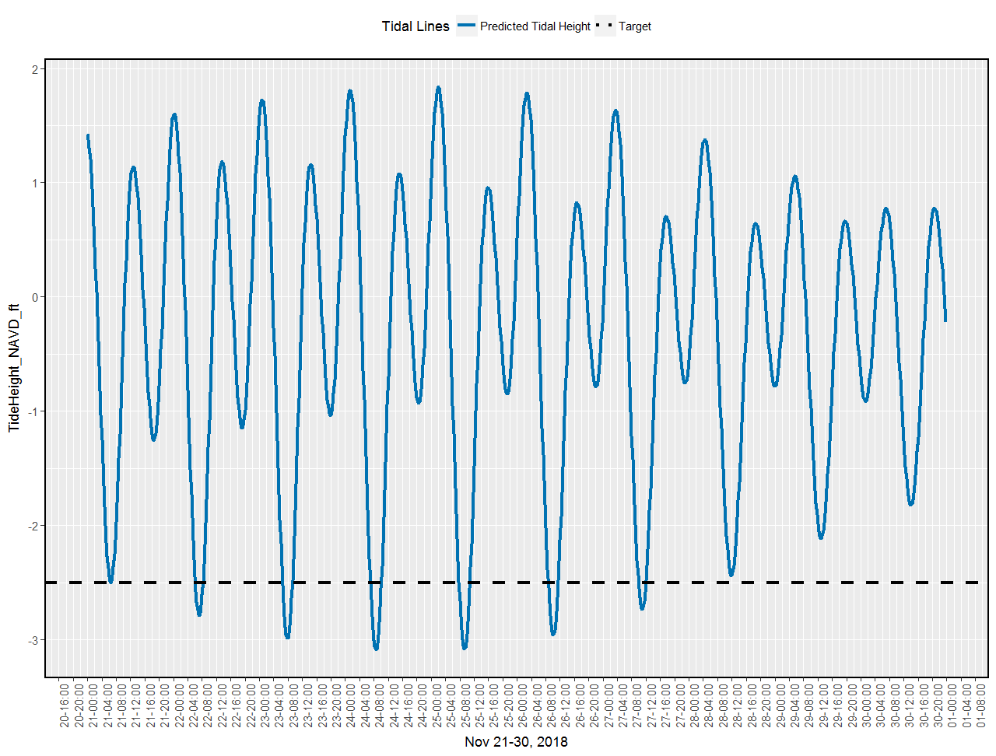



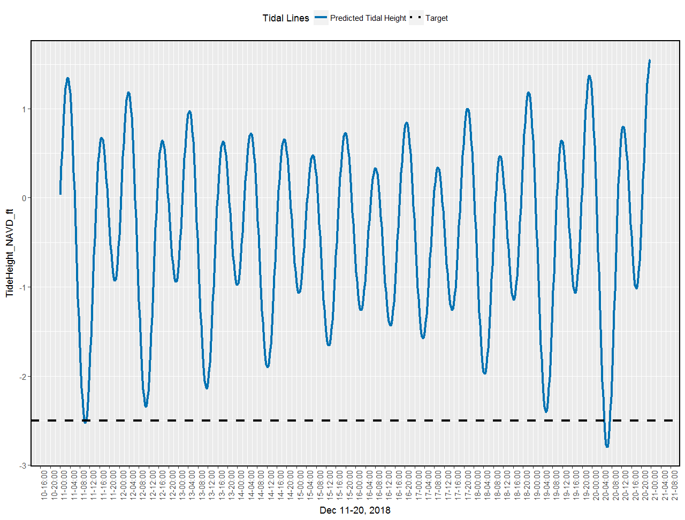

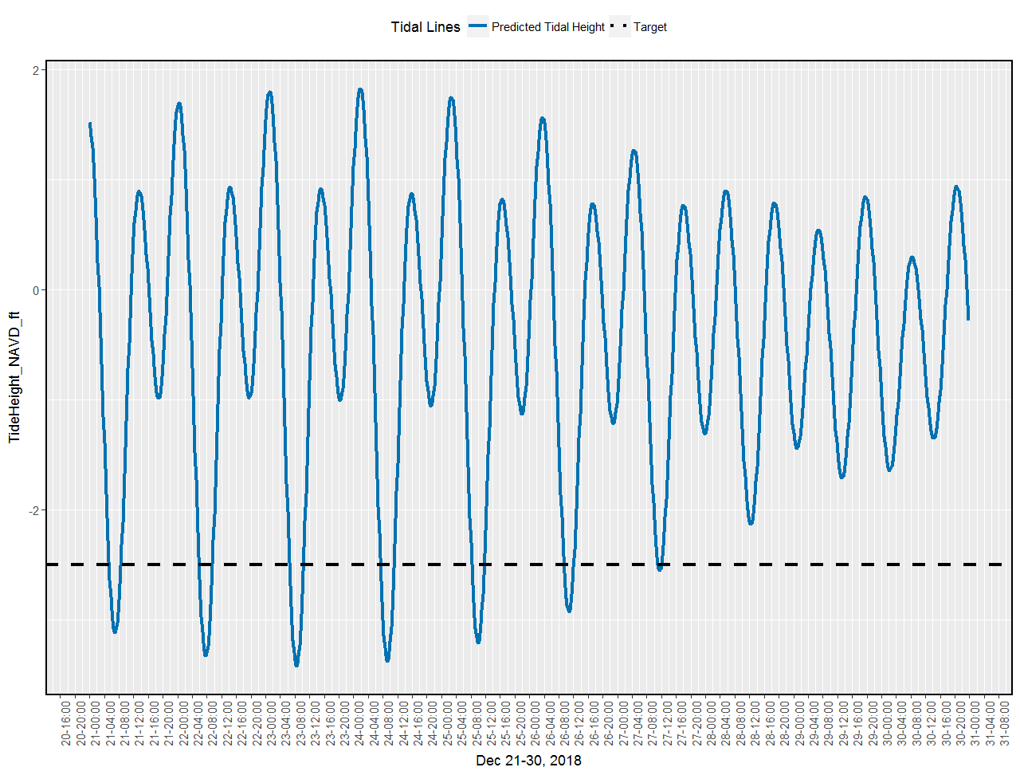

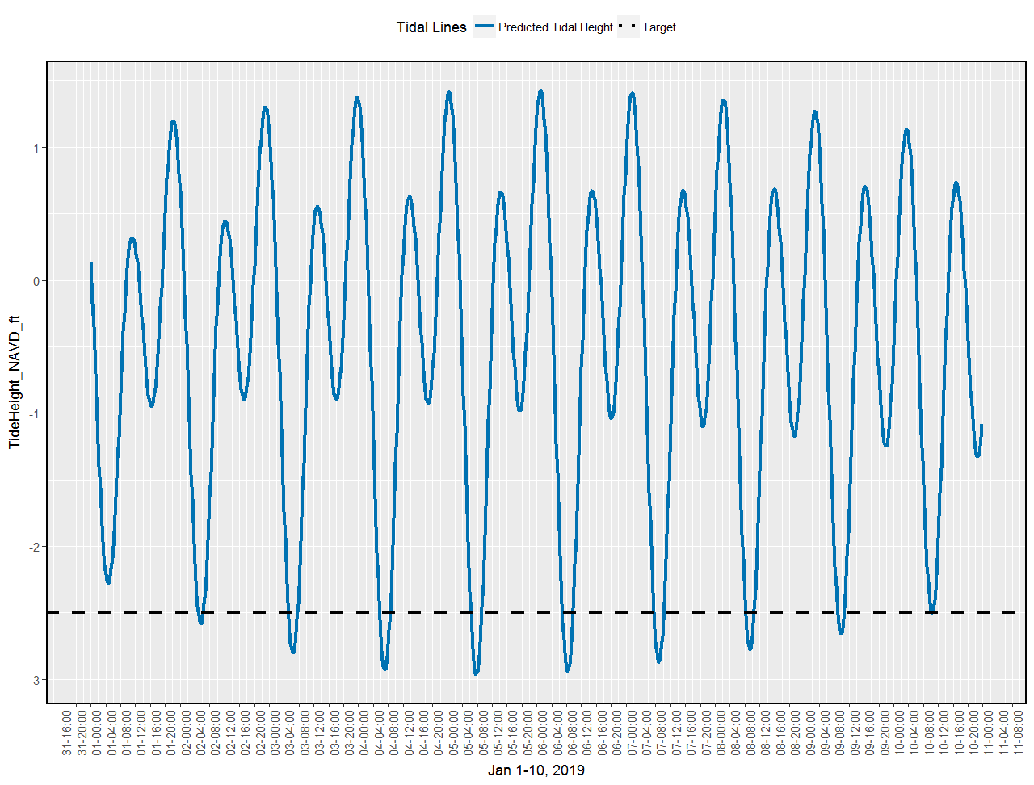

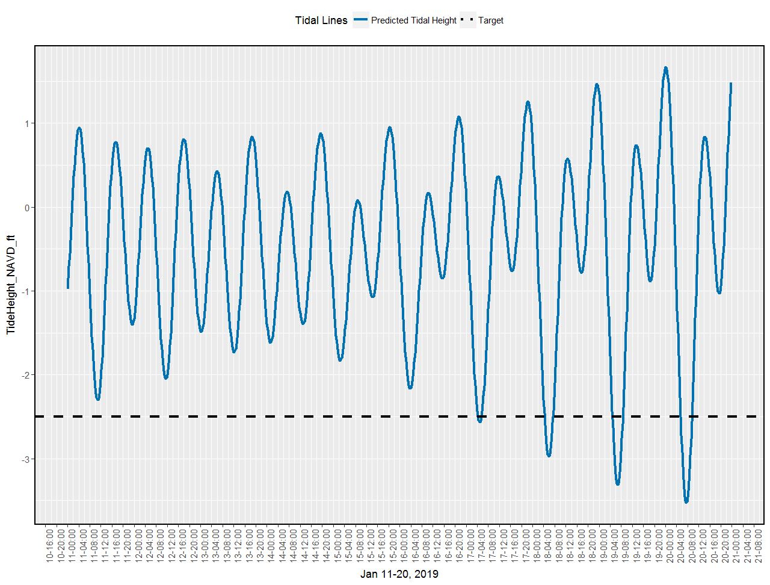

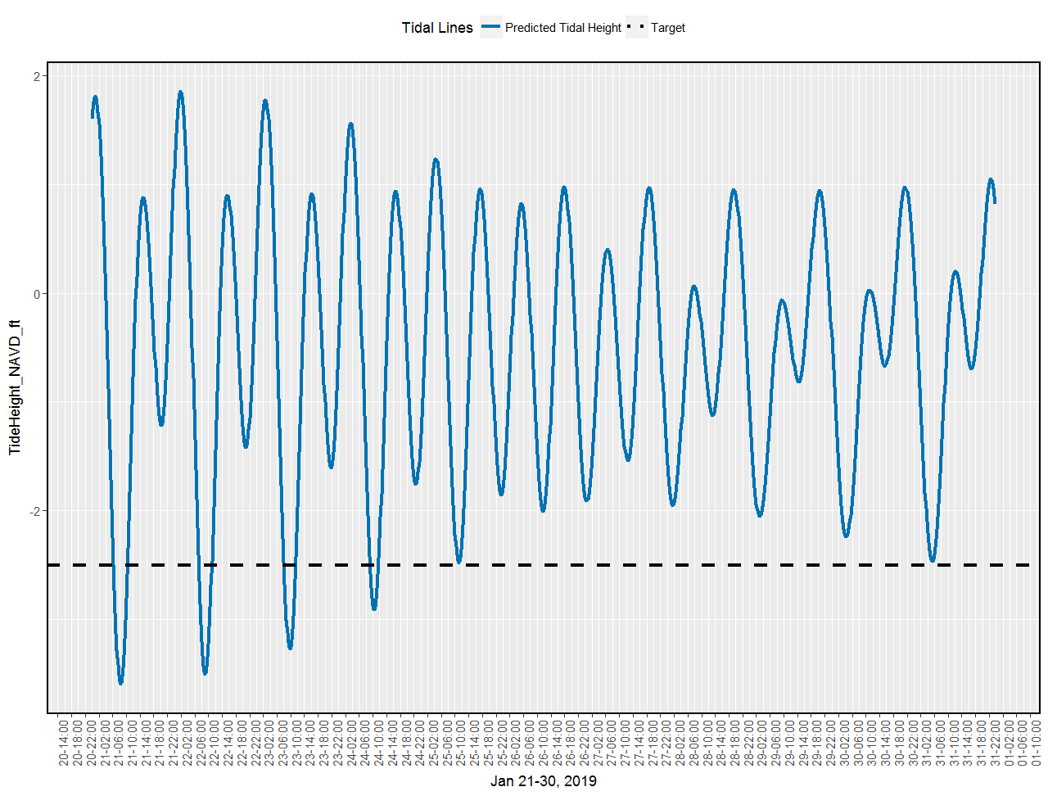

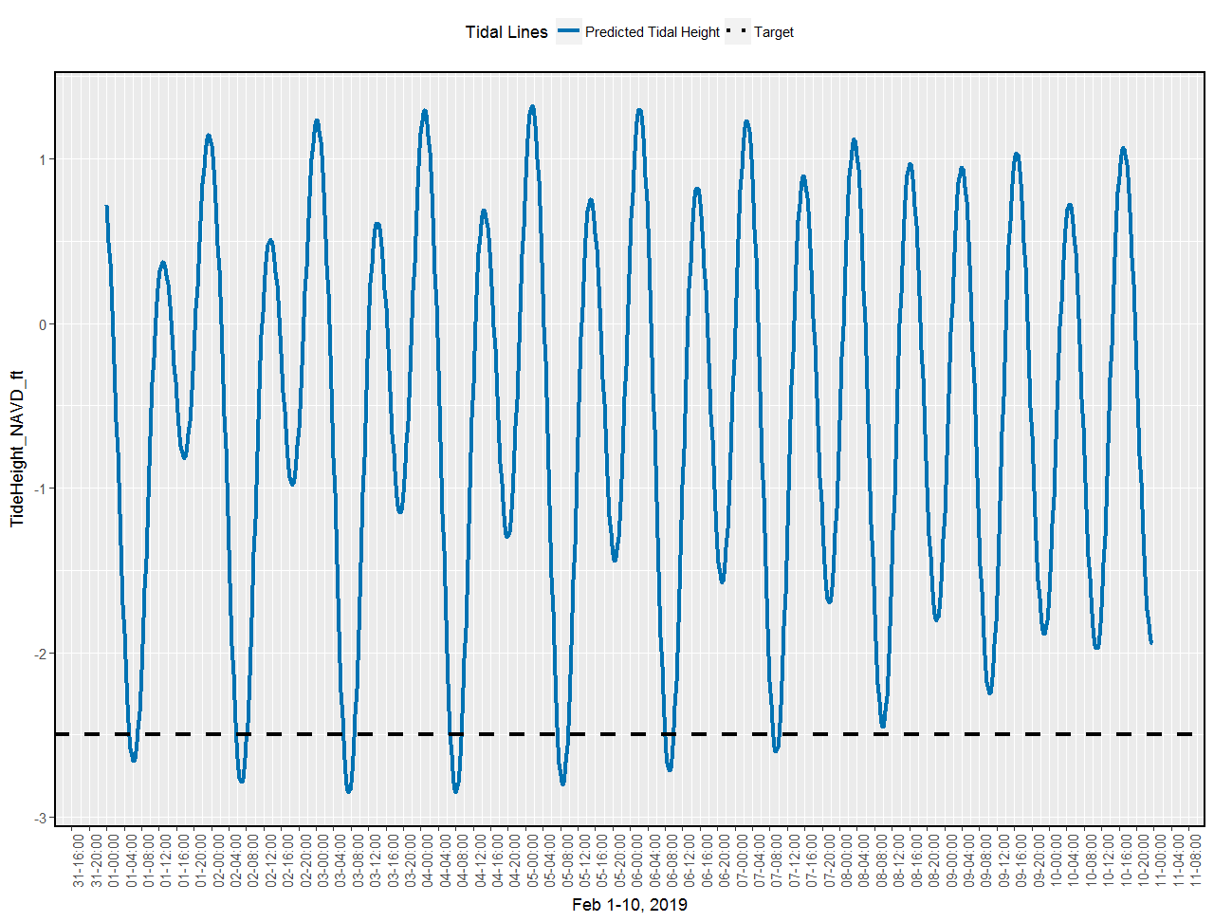

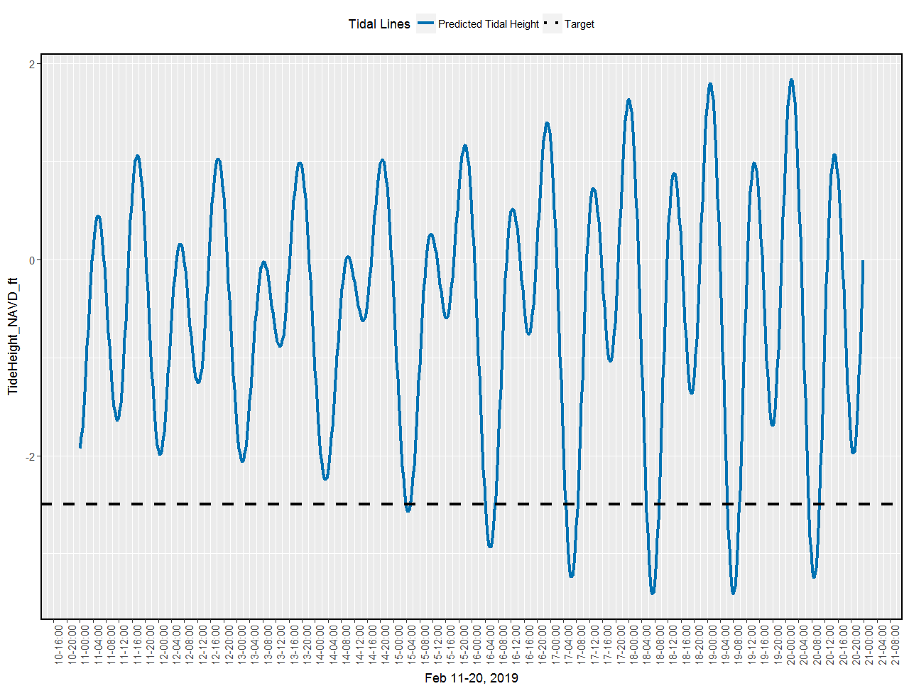





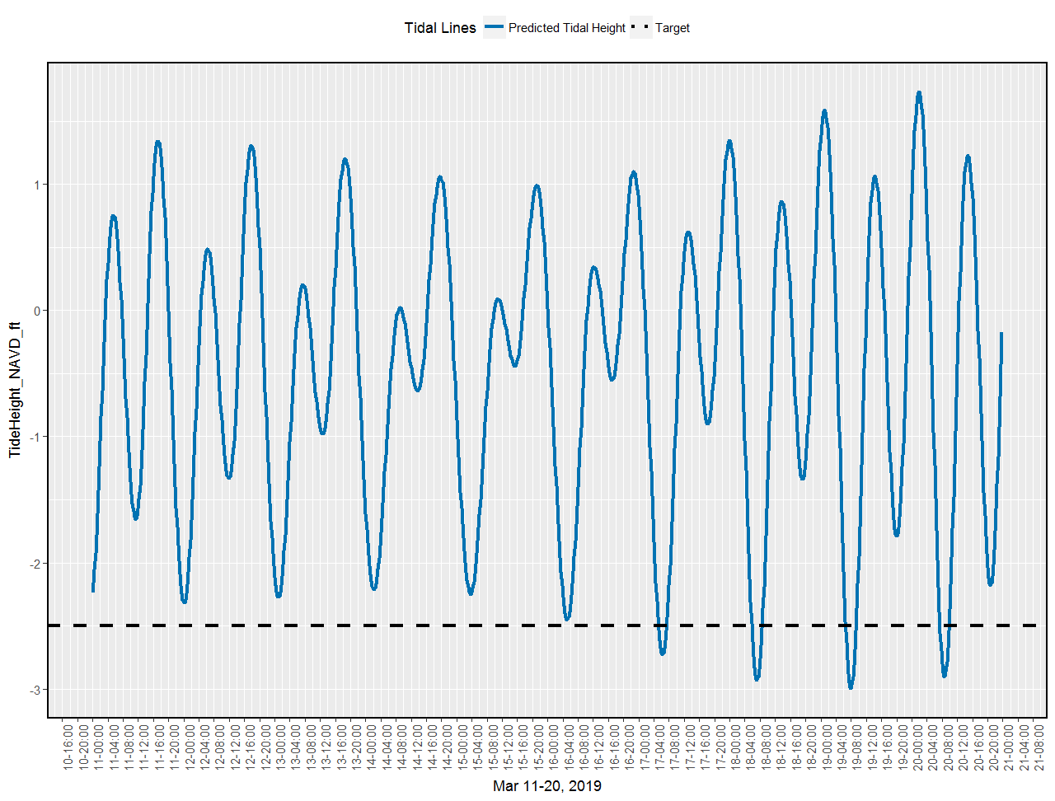

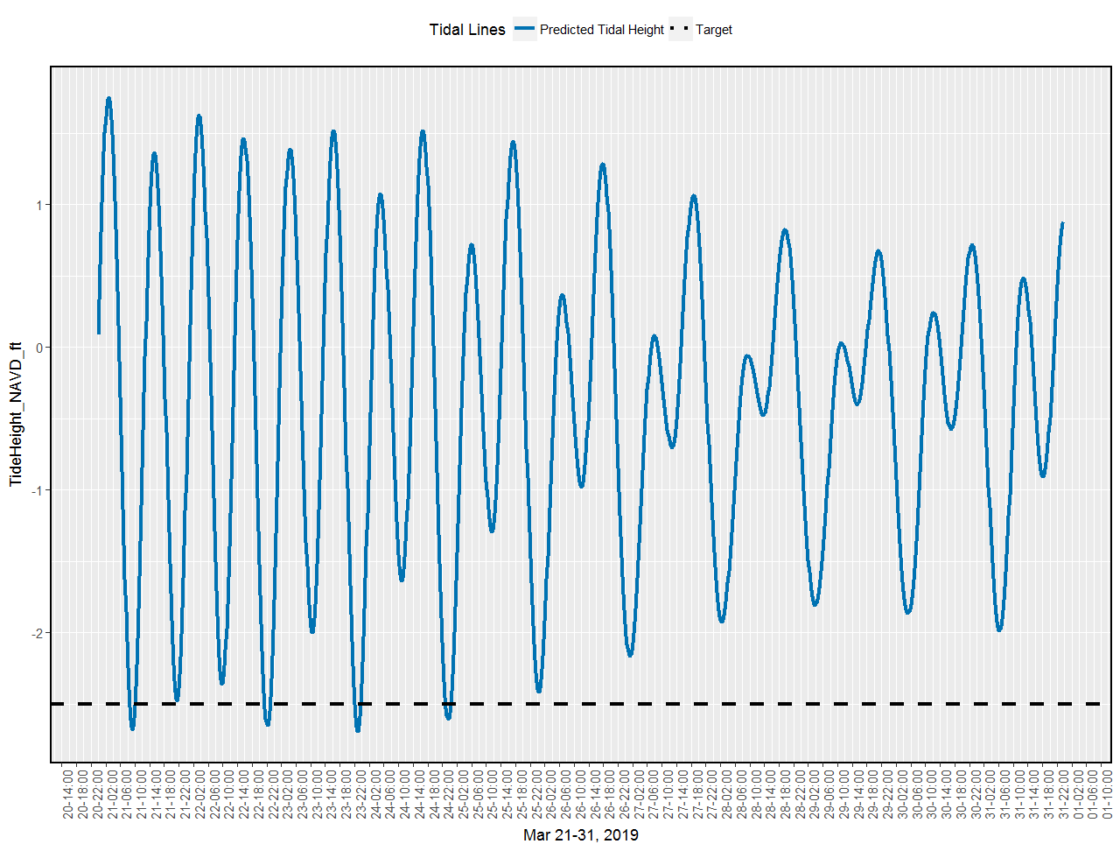

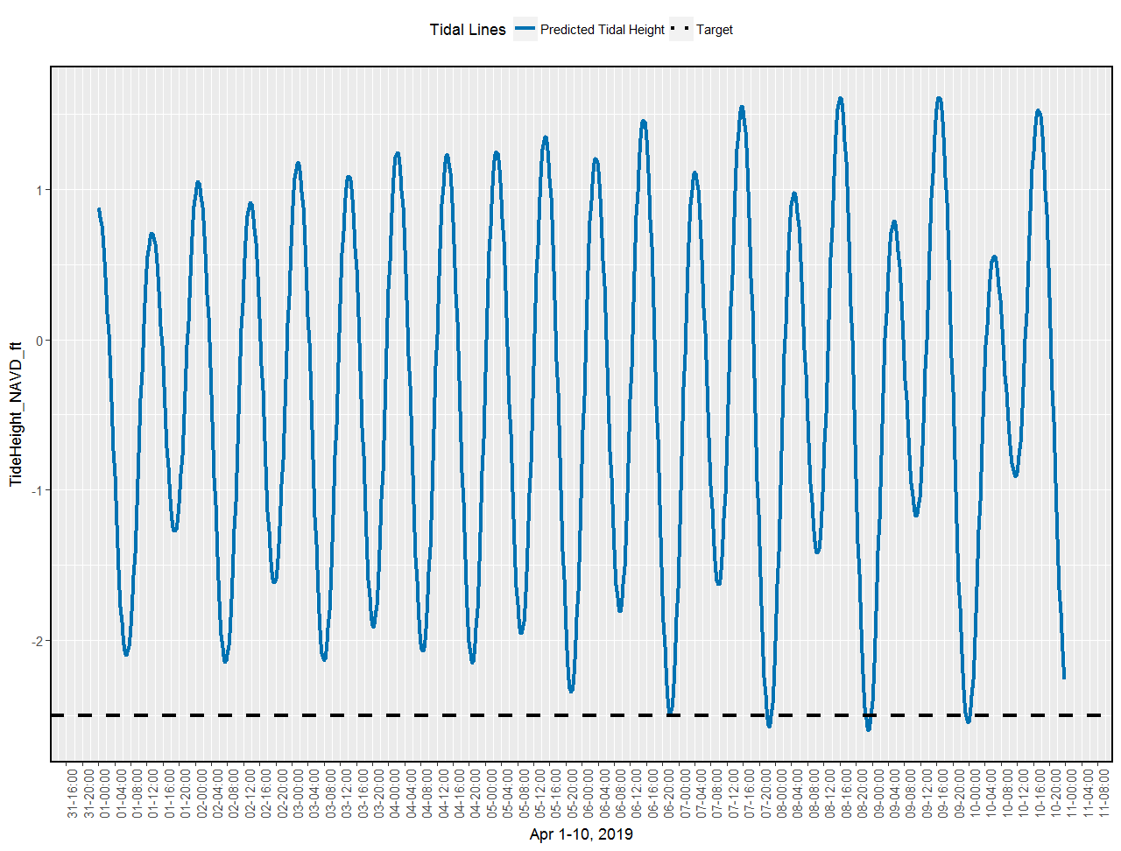

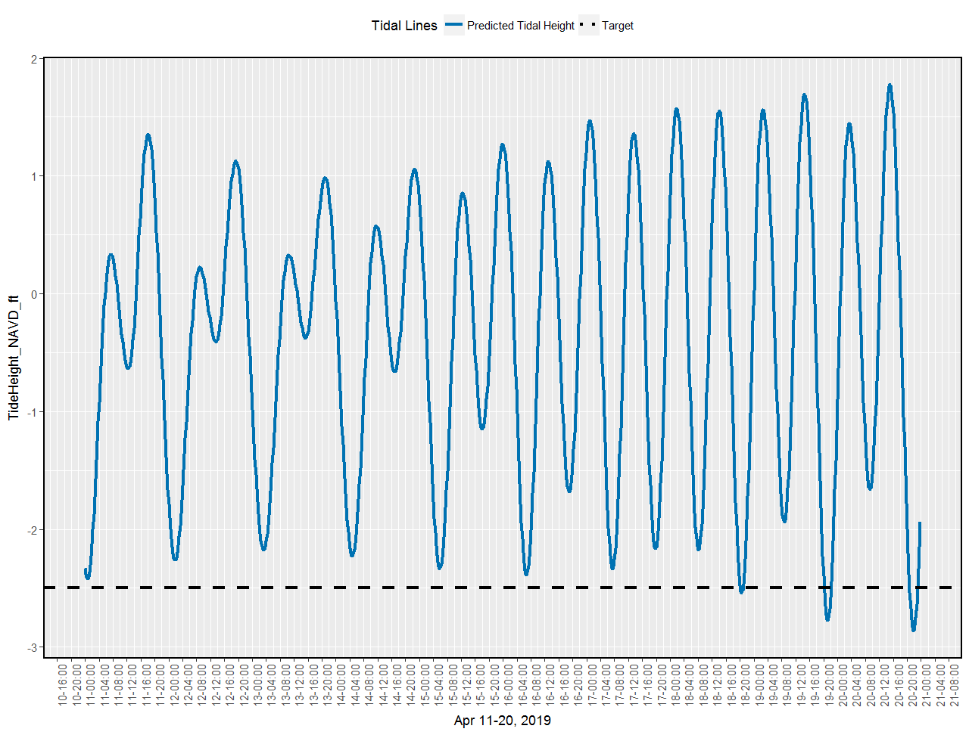



This table gives you the date, time, MLLW in meters, NAVD in meters, and NAVD in ft. The date/times produced are only the 15 minute intervals of time in which the tide is predicted to be below -2.5 NAVD ft. This is from CK_tide_field_sample on the tide_inundation Git repository.

|  |  |  |  |  |  |  |
| --- | --- | --- | --- | --- | --- | --- |
| station |  |  | date_time | tide_mllw_m | tide_navd_m | tide_navd_ft |
| Cedar Key | Gulf Of Mexico | Florida | 2018-10-26 09:15:00 | -0.08 | -0.77 | -2.53 |
| Cedar Key | Gulf Of Mexico | Florida | 2018-10-26 09:30:00 | -0.1 | -0.78 | -2.58 |
| Cedar Key | Gulf Of Mexico | Florida | 2018-10-26 09:45:00 | -0.1 | -0.79 | -2.59 |
| Cedar Key | Gulf Of Mexico | Florida | 2018-10-26 10:00:00 | -0.1 | -0.79 | -2.58 |
| Cedar Key | Gulf Of Mexico | Florida | 2018-10-26 10:15:00 | -0.08 | -0.77 | -2.53 |
| Cedar Key | Gulf Of Mexico | Florida | 2018-10-27 09:45:00 | -0.08 | -0.76 | -2.5 |
| Cedar Key | Gulf Of Mexico | Florida | 2018-10-27 10:00:00 | -0.1 | -0.78 | -2.57 |
| Cedar Key | Gulf Of Mexico | Florida | 2018-10-27 10:15:00 | -0.11 | -0.8 | -2.61 |
| Cedar Key | Gulf Of Mexico | Florida | 2018-10-27 10:30:00 | -0.11 | -0.8 | -2.62 |
| Cedar Key | Gulf Of Mexico | Florida | 2018-10-27 10:45:00 | -0.1 | -0.79 | -2.6 |
| Cedar Key | Gulf Of Mexico | Florida | 2018-10-27 11:00:00 | -0.09 | -0.77 | -2.54 |
| Cedar Key | Gulf Of Mexico | Florida | 2018-10-28 10:45:00 | -0.08 | -0.76 | -2.51 |
| Cedar Key | Gulf Of Mexico | Florida | 2018-10-28 11:00:00 | -0.09 | -0.78 | -2.54 |
| Cedar Key | Gulf Of Mexico | Florida | 2018-10-28 11:15:00 | -0.09 | -0.78 | -2.55 |
| Cedar Key | Gulf Of Mexico | Florida | 2018-10-28 11:30:00 | -0.08 | -0.77 | -2.53 |
| Cedar Key | Gulf Of Mexico | Florida | 2018-11-07 06:45:00 | -0.09 | -0.77 | -2.53 |
| Cedar Key | Gulf Of Mexico | Florida | 2018-11-07 07:00:00 | -0.11 | -0.8 | -2.61 |
| Cedar Key | Gulf Of Mexico | Florida | 2018-11-07 07:15:00 | -0.12 | -0.81 | -2.66 |
| Cedar Key | Gulf Of Mexico | Florida | 2018-11-07 07:30:00 | -0.13 | -0.81 | -2.67 |
| Cedar Key | Gulf Of Mexico | Florida | 2018-11-07 07:45:00 | -0.12 | -0.81 | -2.65 |
| Cedar Key | Gulf Of Mexico | Florida | 2018-11-07 08:00:00 | -0.1 | -0.79 | -2.59 |
| Cedar Key | Gulf Of Mexico | Florida | 2018-11-07 08:15:00 | -0.08 | -0.76 | -2.51 |
| Cedar Key | Gulf Of Mexico | Florida | 2018-11-08 07:15:00 | -0.09 | -0.78 | -2.55 |
| Cedar Key | Gulf Of Mexico | Florida | 2018-11-08 07:30:00 | -0.12 | -0.81 | -2.65 |
| Cedar Key | Gulf Of Mexico | Florida | 2018-11-08 07:45:00 | -0.14 | -0.83 | -2.71 |
| Cedar Key | Gulf Of Mexico | Florida | 2018-11-08 08:00:00 | -0.15 | -0.84 | -2.74 |
| Cedar Key | Gulf Of Mexico | Florida | 2018-11-08 08:15:00 | -0.15 | -0.84 | -2.74 |
| Cedar Key | Gulf Of Mexico | Florida | 2018-11-08 08:30:00 | -0.14 | -0.82 | -2.71 |
| Cedar Key | Gulf Of Mexico | Florida | 2018-11-08 08:45:00 | -0.12 | -0.8 | -2.64 |
| Cedar Key | Gulf Of Mexico | Florida | 2018-11-08 09:00:00 | -0.09 | -0.77 | -2.54 |
| Cedar Key | Gulf Of Mexico | Florida | 2018-11-09 08:00:00 | -0.1 | -0.79 | -2.59 |
| Cedar Key | Gulf Of Mexico | Florida | 2018-11-09 08:15:00 | -0.12 | -0.81 | -2.66 |
| Cedar Key | Gulf Of Mexico | Florida | 2018-11-09 08:30:00 | -0.14 | -0.82 | -2.71 |
| Cedar Key | Gulf Of Mexico | Florida | 2018-11-09 08:45:00 | -0.14 | -0.83 | -2.72 |
| Cedar Key | Gulf Of Mexico | Florida | 2018-11-09 09:00:00 | -0.14 | -0.82 | -2.7 |
| Cedar Key | Gulf Of Mexico | Florida | 2018-11-09 09:15:00 | -0.12 | -0.81 | -2.65 |
| Cedar Key | Gulf Of Mexico | Florida | 2018-11-09 09:30:00 | -0.1 | -0.78 | -2.57 |
| Cedar Key | Gulf Of Mexico | Florida | 2018-11-10 08:45:00 | -0.09 | -0.77 | -2.53 |
| Cedar Key | Gulf Of Mexico | Florida | 2018-11-10 09:00:00 | -0.1 | -0.79 | -2.59 |
| Cedar Key | Gulf Of Mexico | Florida | 2018-11-10 09:15:00 | -0.11 | -0.8 | -2.61 |
| Cedar Key | Gulf Of Mexico | Florida | 2018-11-10 09:30:00 | -0.11 | -0.79 | -2.6 |
| Cedar Key | Gulf Of Mexico | Florida | 2018-11-10 09:45:00 | -0.1 | -0.78 | -2.57 |
| Cedar Key | Gulf Of Mexico | Florida | 2018-11-10 10:00:00 | -0.08 | -0.76 | -2.51 |
| Cedar Key | Gulf Of Mexico | Florida | 2018-11-22 06:15:00 | -0.1 | -0.79 | -2.58 |
| Cedar Key | Gulf Of Mexico | Florida | 2018-11-22 06:30:00 | -0.13 | -0.82 | -2.67 |
| Cedar Key | Gulf Of Mexico | Florida | 2018-11-22 06:45:00 | -0.15 | -0.84 | -2.74 |
| Cedar Key | Gulf Of Mexico | Florida | 2018-11-22 07:00:00 | -0.16 | -0.85 | -2.78 |
| Cedar Key | Gulf Of Mexico | Florida | 2018-11-22 07:15:00 | -0.16 | -0.85 | -2.79 |
| Cedar Key | Gulf Of Mexico | Florida | 2018-11-22 07:30:00 | -0.15 | -0.84 | -2.76 |
| Cedar Key | Gulf Of Mexico | Florida | 2018-11-22 07:45:00 | -0.14 | -0.82 | -2.7 |
| Cedar Key | Gulf Of Mexico | Florida | 2018-11-22 08:00:00 | -0.11 | -0.79 | -2.61 |
| Cedar Key | Gulf Of Mexico | Florida | 2018-11-23 06:30:00 | -0.08 | -0.77 | -2.52 |
| Cedar Key | Gulf Of Mexico | Florida | 2018-11-23 06:45:00 | -0.13 | -0.81 | -2.67 |
| Cedar Key | Gulf Of Mexico | Florida | 2018-11-23 07:00:00 | -0.17 | -0.85 | -2.8 |
| Cedar Key | Gulf Of Mexico | Florida | 2018-11-23 07:15:00 | -0.19 | -0.88 | -2.89 |
| Cedar Key | Gulf Of Mexico | Florida | 2018-11-23 07:30:00 | -0.21 | -0.9 | -2.95 |
| Cedar Key | Gulf Of Mexico | Florida | 2018-11-23 07:45:00 | -0.22 | -0.91 | -2.99 |
| Cedar Key | Gulf Of Mexico | Florida | 2018-11-23 08:00:00 | -0.22 | -0.91 | -2.98 |
| Cedar Key | Gulf Of Mexico | Florida | 2018-11-23 08:15:00 | -0.21 | -0.9 | -2.95 |
| Cedar Key | Gulf Of Mexico | Florida | 2018-11-23 08:30:00 | -0.19 | -0.88 | -2.87 |
| Cedar Key | Gulf Of Mexico | Florida | 2018-11-23 08:45:00 | -0.16 | -0.84 | -2.77 |
| Cedar Key | Gulf Of Mexico | Florida | 2018-11-23 09:00:00 | -0.12 | -0.8 | -2.64 |
| Cedar Key | Gulf Of Mexico | Florida | 2018-11-24 07:15:00 | -0.12 | -0.81 | -2.65 |
| Cedar Key | Gulf Of Mexico | Florida | 2018-11-24 07:30:00 | -0.16 | -0.85 | -2.79 |
| Cedar Key | Gulf Of Mexico | Florida | 2018-11-24 07:45:00 | -0.2 | -0.89 | -2.91 |
| Cedar Key | Gulf Of Mexico | Florida | 2018-11-24 08:00:00 | -0.23 | -0.92 | -3 |
| Cedar Key | Gulf Of Mexico | Florida | 2018-11-24 08:15:00 | -0.25 | -0.93 | -3.06 |
| Cedar Key | Gulf Of Mexico | Florida | 2018-11-24 08:30:00 | -0.25 | -0.94 | -3.09 |
| Cedar Key | Gulf Of Mexico | Florida | 2018-11-24 08:45:00 | -0.25 | -0.94 | -3.08 |
| Cedar Key | Gulf Of Mexico | Florida | 2018-11-24 09:00:00 | -0.24 | -0.93 | -3.04 |
| Cedar Key | Gulf Of Mexico | Florida | 2018-11-24 09:15:00 | -0.21 | -0.9 | -2.96 |
| Cedar Key | Gulf Of Mexico | Florida | 2018-11-24 09:30:00 | -0.18 | -0.87 | -2.85 |
| Cedar Key | Gulf Of Mexico | Florida | 2018-11-24 09:45:00 | -0.14 | -0.83 | -2.71 |
| Cedar Key | Gulf Of Mexico | Florida | 2018-11-24 10:00:00 | -0.09 | -0.78 | -2.55 |
| Cedar Key | Gulf Of Mexico | Florida | 2018-11-25 08:00:00 | -0.12 | -0.81 | -2.66 |
| Cedar Key | Gulf Of Mexico | Florida | 2018-11-25 08:15:00 | -0.17 | -0.85 | -2.8 |
| Cedar Key | Gulf Of Mexico | Florida | 2018-11-25 08:30:00 | -0.2 | -0.89 | -2.91 |
| Cedar Key | Gulf Of Mexico | Florida | 2018-11-25 08:45:00 | -0.23 | -0.91 | -3 |
| Cedar Key | Gulf Of Mexico | Florida | 2018-11-25 09:00:00 | -0.24 | -0.93 | -3.05 |
| Cedar Key | Gulf Of Mexico | Florida | 2018-11-25 09:15:00 | -0.25 | -0.94 | -3.08 |
| Cedar Key | Gulf Of Mexico | Florida | 2018-11-25 09:30:00 | -0.25 | -0.94 | -3.07 |
| Cedar Key | Gulf Of Mexico | Florida | 2018-11-25 09:45:00 | -0.24 | -0.92 | -3.03 |
| Cedar Key | Gulf Of Mexico | Florida | 2018-11-25 10:00:00 | -0.21 | -0.9 | -2.95 |
| Cedar Key | Gulf Of Mexico | Florida | 2018-11-25 10:15:00 | -0.18 | -0.87 | -2.84 |
| Cedar Key | Gulf Of Mexico | Florida | 2018-11-25 10:30:00 | -0.14 | -0.83 | -2.71 |
| Cedar Key | Gulf Of Mexico | Florida | 2018-11-25 10:45:00 | -0.09 | -0.78 | -2.55 |
| Cedar Key | Gulf Of Mexico | Florida | 2018-11-26 08:45:00 | -0.09 | -0.77 | -2.54 |
| Cedar Key | Gulf Of Mexico | Florida | 2018-11-26 09:00:00 | -0.13 | -0.82 | -2.68 |
| Cedar Key | Gulf Of Mexico | Florida | 2018-11-26 09:15:00 | -0.16 | -0.85 | -2.79 |
| Cedar Key | Gulf Of Mexico | Florida | 2018-11-26 09:30:00 | -0.19 | -0.88 | -2.87 |
| Cedar Key | Gulf Of Mexico | Florida | 2018-11-26 09:45:00 | -0.21 | -0.89 | -2.93 |
| Cedar Key | Gulf Of Mexico | Florida | 2018-11-26 10:00:00 | -0.21 | -0.9 | -2.96 |
| Cedar Key | Gulf Of Mexico | Florida | 2018-11-26 10:15:00 | -0.21 | -0.9 | -2.95 |
| Cedar Key | Gulf Of Mexico | Florida | 2018-11-26 10:30:00 | -0.2 | -0.89 | -2.92 |
| Cedar Key | Gulf Of Mexico | Florida | 2018-11-26 10:45:00 | -0.18 | -0.87 | -2.85 |
| Cedar Key | Gulf Of Mexico | Florida | 2018-11-26 11:00:00 | -0.15 | -0.84 | -2.75 |
| Cedar Key | Gulf Of Mexico | Florida | 2018-11-26 11:15:00 | -0.11 | -0.8 | -2.63 |
| Cedar Key | Gulf Of Mexico | Florida | 2018-11-27 10:00:00 | -0.09 | -0.78 | -2.55 |
| Cedar Key | Gulf Of Mexico | Florida | 2018-11-27 10:15:00 | -0.12 | -0.8 | -2.63 |
| Cedar Key | Gulf Of Mexico | Florida | 2018-11-27 10:30:00 | -0.13 | -0.82 | -2.7 |
| Cedar Key | Gulf Of Mexico | Florida | 2018-11-27 10:45:00 | -0.14 | -0.83 | -2.73 |
| Cedar Key | Gulf Of Mexico | Florida | 2018-11-27 11:00:00 | -0.15 | -0.83 | -2.74 |
| Cedar Key | Gulf Of Mexico | Florida | 2018-11-27 11:15:00 | -0.14 | -0.83 | -2.71 |
| Cedar Key | Gulf Of Mexico | Florida | 2018-11-27 11:30:00 | -0.12 | -0.81 | -2.66 |
| Cedar Key | Gulf Of Mexico | Florida | 2018-11-27 11:45:00 | -0.1 | -0.79 | -2.59 |
| Cedar Key | Gulf Of Mexico | Florida | 2018-12-05 05:45:00 | -0.1 | -0.79 | -2.59 |
| Cedar Key | Gulf Of Mexico | Florida | 2018-12-05 06:00:00 | -0.13 | -0.82 | -2.68 |
| Cedar Key | Gulf Of Mexico | Florida | 2018-12-05 06:15:00 | -0.14 | -0.83 | -2.73 |
| Cedar Key | Gulf Of Mexico | Florida | 2018-12-05 06:30:00 | -0.15 | -0.84 | -2.75 |
| Cedar Key | Gulf Of Mexico | Florida | 2018-12-05 06:45:00 | -0.15 | -0.84 | -2.75 |
| Cedar Key | Gulf Of Mexico | Florida | 2018-12-05 07:00:00 | -0.14 | -0.83 | -2.71 |
| Cedar Key | Gulf Of Mexico | Florida | 2018-12-05 07:15:00 | -0.12 | -0.81 | -2.65 |
| Cedar Key | Gulf Of Mexico | Florida | 2018-12-05 07:30:00 | -0.09 | -0.78 | -2.56 |
| Cedar Key | Gulf Of Mexico | Florida | 2018-12-06 06:00:00 | -0.08 | -0.77 | -2.52 |
| Cedar Key | Gulf Of Mexico | Florida | 2018-12-06 06:15:00 | -0.12 | -0.81 | -2.66 |
| Cedar Key | Gulf Of Mexico | Florida | 2018-12-06 06:30:00 | -0.16 | -0.84 | -2.76 |
| Cedar Key | Gulf Of Mexico | Florida | 2018-12-06 06:45:00 | -0.18 | -0.87 | -2.84 |
| Cedar Key | Gulf Of Mexico | Florida | 2018-12-06 07:00:00 | -0.19 | -0.88 | -2.89 |
| Cedar Key | Gulf Of Mexico | Florida | 2018-12-06 07:15:00 | -0.2 | -0.89 | -2.9 |
| Cedar Key | Gulf Of Mexico | Florida | 2018-12-06 07:30:00 | -0.19 | -0.88 | -2.89 |
| Cedar Key | Gulf Of Mexico | Florida | 2018-12-06 07:45:00 | -0.18 | -0.87 | -2.84 |
| Cedar Key | Gulf Of Mexico | Florida | 2018-12-06 08:00:00 | -0.16 | -0.84 | -2.77 |
| Cedar Key | Gulf Of Mexico | Florida | 2018-12-06 08:15:00 | -0.13 | -0.81 | -2.66 |
| Cedar Key | Gulf Of Mexico | Florida | 2018-12-06 08:30:00 | -0.09 | -0.77 | -2.54 |
| Cedar Key | Gulf Of Mexico | Florida | 2018-12-07 06:45:00 | -0.12 | -0.8 | -2.63 |
| Cedar Key | Gulf Of Mexico | Florida | 2018-12-07 07:00:00 | -0.15 | -0.84 | -2.75 |
| Cedar Key | Gulf Of Mexico | Florida | 2018-12-07 07:15:00 | -0.18 | -0.87 | -2.85 |
| Cedar Key | Gulf Of Mexico | Florida | 2018-12-07 07:30:00 | -0.2 | -0.89 | -2.91 |
| Cedar Key | Gulf Of Mexico | Florida | 2018-12-07 07:45:00 | -0.21 | -0.9 | -2.94 |
| Cedar Key | Gulf Of Mexico | Florida | 2018-12-07 08:00:00 | -0.21 | -0.9 | -2.94 |
| Cedar Key | Gulf Of Mexico | Florida | 2018-12-07 08:15:00 | -0.2 | -0.89 | -2.91 |
| Cedar Key | Gulf Of Mexico | Florida | 2018-12-07 08:30:00 | -0.18 | -0.87 | -2.85 |
| Cedar Key | Gulf Of Mexico | Florida | 2018-12-07 08:45:00 | -0.15 | -0.84 | -2.76 |
| Cedar Key | Gulf Of Mexico | Florida | 2018-12-07 09:00:00 | -0.12 | -0.81 | -2.64 |
| Cedar Key | Gulf Of Mexico | Florida | 2018-12-07 09:15:00 | -0.08 | -0.76 | -2.5 |
| Cedar Key | Gulf Of Mexico | Florida | 2018-12-08 07:15:00 | -0.09 | -0.78 | -2.55 |
| Cedar Key | Gulf Of Mexico | Florida | 2018-12-08 07:30:00 | -0.13 | -0.82 | -2.68 |
| Cedar Key | Gulf Of Mexico | Florida | 2018-12-08 07:45:00 | -0.16 | -0.85 | -2.78 |
| Cedar Key | Gulf Of Mexico | Florida | 2018-12-08 08:00:00 | -0.18 | -0.87 | -2.85 |
| Cedar Key | Gulf Of Mexico | Florida | 2018-12-08 08:15:00 | -0.19 | -0.88 | -2.89 |
| Cedar Key | Gulf Of Mexico | Florida | 2018-12-08 08:30:00 | -0.2 | -0.88 | -2.9 |
| Cedar Key | Gulf Of Mexico | Florida | 2018-12-08 08:45:00 | -0.19 | -0.88 | -2.88 |
| Cedar Key | Gulf Of Mexico | Florida | 2018-12-08 09:00:00 | -0.18 | -0.86 | -2.84 |
| Cedar Key | Gulf Of Mexico | Florida | 2018-12-08 09:15:00 | -0.15 | -0.84 | -2.76 |
| Cedar Key | Gulf Of Mexico | Florida | 2018-12-08 09:30:00 | -0.12 | -0.81 | -2.66 |
| Cedar Key | Gulf Of Mexico | Florida | 2018-12-08 09:45:00 | -0.08 | -0.77 | -2.53 |
| Cedar Key | Gulf Of Mexico | Florida | 2018-12-09 08:00:00 | -0.09 | -0.78 | -2.56 |
| Cedar Key | Gulf Of Mexico | Florida | 2018-12-09 08:15:00 | -0.12 | -0.81 | -2.66 |
| Cedar Key | Gulf Of Mexico | Florida | 2018-12-09 08:30:00 | -0.15 | -0.83 | -2.74 |
| Cedar Key | Gulf Of Mexico | Florida | 2018-12-09 08:45:00 | -0.16 | -0.85 | -2.79 |
| Cedar Key | Gulf Of Mexico | Florida | 2018-12-09 09:00:00 | -0.17 | -0.86 | -2.81 |
| Cedar Key | Gulf Of Mexico | Florida | 2018-12-09 09:15:00 | -0.17 | -0.85 | -2.8 |
| Cedar Key | Gulf Of Mexico | Florida | 2018-12-09 09:30:00 | -0.15 | -0.84 | -2.76 |
| Cedar Key | Gulf Of Mexico | Florida | 2018-12-09 09:45:00 | -0.13 | -0.82 | -2.7 |
| Cedar Key | Gulf Of Mexico | Florida | 2018-12-09 10:00:00 | -0.11 | -0.79 | -2.6 |
| Cedar Key | Gulf Of Mexico | Florida | 2018-12-10 08:45:00 | -0.08 | -0.77 | -2.52 |
| Cedar Key | Gulf Of Mexico | Florida | 2018-12-10 09:00:00 | -0.11 | -0.79 | -2.6 |
| Cedar Key | Gulf Of Mexico | Florida | 2018-12-10 09:15:00 | -0.12 | -0.81 | -2.65 |
| Cedar Key | Gulf Of Mexico | Florida | 2018-12-10 09:30:00 | -0.13 | -0.82 | -2.68 |
| Cedar Key | Gulf Of Mexico | Florida | 2018-12-10 09:45:00 | -0.13 | -0.82 | -2.68 |
| Cedar Key | Gulf Of Mexico | Florida | 2018-12-10 10:00:00 | -0.12 | -0.81 | -2.65 |
| Cedar Key | Gulf Of Mexico | Florida | 2018-12-10 10:15:00 | -0.1 | -0.79 | -2.59 |
| Cedar Key | Gulf Of Mexico | Florida | 2018-12-10 10:30:00 | -0.08 | -0.77 | -2.51 |
| Cedar Key | Gulf Of Mexico | Florida | 2018-12-11 10:00:00 | -0.08 | -0.77 | -2.52 |
| Cedar Key | Gulf Of Mexico | Florida | 2018-12-11 10:15:00 | -0.08 | -0.77 | -2.53 |
| Cedar Key | Gulf Of Mexico | Florida | 2018-12-11 10:30:00 | -0.08 | -0.76 | -2.51 |
| Cedar Key | Gulf Of Mexico | Florida | 2018-12-20 05:00:00 | -0.08 | -0.77 | -2.52 |
| Cedar Key | Gulf Of Mexico | Florida | 2018-12-20 05:15:00 | -0.11 | -0.8 | -2.63 |
| Cedar Key | Gulf Of Mexico | Florida | 2018-12-20 05:30:00 | -0.14 | -0.83 | -2.71 |
| Cedar Key | Gulf Of Mexico | Florida | 2018-12-20 05:45:00 | -0.16 | -0.84 | -2.77 |
| Cedar Key | Gulf Of Mexico | Florida | 2018-12-20 06:00:00 | -0.16 | -0.85 | -2.79 |
| Cedar Key | Gulf Of Mexico | Florida | 2018-12-20 06:15:00 | -0.16 | -0.85 | -2.79 |
| Cedar Key | Gulf Of Mexico | Florida | 2018-12-20 06:30:00 | -0.16 | -0.84 | -2.76 |
| Cedar Key | Gulf Of Mexico | Florida | 2018-12-20 06:45:00 | -0.14 | -0.83 | -2.71 |
| Cedar Key | Gulf Of Mexico | Florida | 2018-12-20 07:00:00 | -0.11 | -0.8 | -2.62 |
| Cedar Key | Gulf Of Mexico | Florida | 2018-12-20 07:15:00 | -0.08 | -0.77 | -2.52 |
| Cedar Key | Gulf Of Mexico | Florida | 2018-12-21 05:30:00 | -0.12 | -0.8 | -2.64 |
| Cedar Key | Gulf Of Mexico | Florida | 2018-12-21 05:45:00 | -0.16 | -0.85 | -2.79 |
| Cedar Key | Gulf Of Mexico | Florida | 2018-12-21 06:00:00 | -0.2 | -0.89 | -2.91 |
| Cedar Key | Gulf Of Mexico | Florida | 2018-12-21 06:15:00 | -0.23 | -0.92 | -3.01 |
| Cedar Key | Gulf Of Mexico | Florida | 2018-12-21 06:30:00 | -0.25 | -0.94 | -3.07 |
| Cedar Key | Gulf Of Mexico | Florida | 2018-12-21 06:45:00 | -0.26 | -0.95 | -3.11 |
| Cedar Key | Gulf Of Mexico | Florida | 2018-12-21 07:00:00 | -0.26 | -0.95 | -3.11 |
| Cedar Key | Gulf Of Mexico | Florida | 2018-12-21 07:15:00 | -0.25 | -0.94 | -3.08 |
| Cedar Key | Gulf Of Mexico | Florida | 2018-12-21 07:30:00 | -0.23 | -0.92 | -3.02 |
| Cedar Key | Gulf Of Mexico | Florida | 2018-12-21 07:45:00 | -0.21 | -0.89 | -2.93 |
| Cedar Key | Gulf Of Mexico | Florida | 2018-12-21 08:00:00 | -0.17 | -0.86 | -2.82 |
| Cedar Key | Gulf Of Mexico | Florida | 2018-12-21 08:15:00 | -0.13 | -0.81 | -2.67 |
| Cedar Key | Gulf Of Mexico | Florida | 2018-12-21 08:30:00 | -0.08 | -0.76 | -2.51 |
| Cedar Key | Gulf Of Mexico | Florida | 2018-12-22 06:00:00 | -0.11 | -0.8 | -2.63 |
| Cedar Key | Gulf Of Mexico | Florida | 2018-12-22 06:15:00 | -0.17 | -0.86 | -2.81 |
| Cedar Key | Gulf Of Mexico | Florida | 2018-12-22 06:30:00 | -0.22 | -0.91 | -2.97 |
| Cedar Key | Gulf Of Mexico | Florida | 2018-12-22 06:45:00 | -0.26 | -0.95 | -3.1 |
| Cedar Key | Gulf Of Mexico | Florida | 2018-12-22 07:00:00 | -0.29 | -0.98 | -3.21 |
| Cedar Key | Gulf Of Mexico | Florida | 2018-12-22 07:15:00 | -0.31 | -1 | -3.28 |
| Cedar Key | Gulf Of Mexico | Florida | 2018-12-22 07:30:00 | -0.33 | -1.01 | -3.32 |
| Cedar Key | Gulf Of Mexico | Florida | 2018-12-22 07:45:00 | -0.33 | -1.01 | -3.33 |
| Cedar Key | Gulf Of Mexico | Florida | 2018-12-22 08:00:00 | -0.32 | -1.01 | -3.3 |
| Cedar Key | Gulf Of Mexico | Florida | 2018-12-22 08:15:00 | -0.3 | -0.99 | -3.24 |
| Cedar Key | Gulf Of Mexico | Florida | 2018-12-22 08:30:00 | -0.27 | -0.96 | -3.14 |
| Cedar Key | Gulf Of Mexico | Florida | 2018-12-22 08:45:00 | -0.23 | -0.92 | -3.02 |
| Cedar Key | Gulf Of Mexico | Florida | 2018-12-22 09:00:00 | -0.19 | -0.87 | -2.86 |
| Cedar Key | Gulf Of Mexico | Florida | 2018-12-22 09:15:00 | -0.13 | -0.82 | -2.69 |
| Cedar Key | Gulf Of Mexico | Florida | 2018-12-23 06:45:00 | -0.13 | -0.82 | -2.69 |
| Cedar Key | Gulf Of Mexico | Florida | 2018-12-23 07:00:00 | -0.19 | -0.88 | -2.88 |
| Cedar Key | Gulf Of Mexico | Florida | 2018-12-23 07:15:00 | -0.24 | -0.93 | -3.05 |
| Cedar Key | Gulf Of Mexico | Florida | 2018-12-23 07:30:00 | -0.28 | -0.97 | -3.18 |
| Cedar Key | Gulf Of Mexico | Florida | 2018-12-23 07:45:00 | -0.32 | -1 | -3.29 |
| Cedar Key | Gulf Of Mexico | Florida | 2018-12-23 08:00:00 | -0.34 | -1.03 | -3.37 |
| Cedar Key | Gulf Of Mexico | Florida | 2018-12-23 08:15:00 | -0.35 | -1.04 | -3.41 |
| Cedar Key | Gulf Of Mexico | Florida | 2018-12-23 08:30:00 | -0.35 | -1.04 | -3.42 |
| Cedar Key | Gulf Of Mexico | Florida | 2018-12-23 08:45:00 | -0.35 | -1.03 | -3.39 |
| Cedar Key | Gulf Of Mexico | Florida | 2018-12-23 09:00:00 | -0.33 | -1.01 | -3.33 |
| Cedar Key | Gulf Of Mexico | Florida | 2018-12-23 09:15:00 | -0.3 | -0.98 | -3.23 |
| Cedar Key | Gulf Of Mexico | Florida | 2018-12-23 09:30:00 | -0.26 | -0.95 | -3.1 |
| Cedar Key | Gulf Of Mexico | Florida | 2018-12-23 09:45:00 | -0.21 | -0.9 | -2.94 |
| Cedar Key | Gulf Of Mexico | Florida | 2018-12-23 10:00:00 | -0.16 | -0.84 | -2.76 |
| Cedar Key | Gulf Of Mexico | Florida | 2018-12-23 10:15:00 | -0.09 | -0.78 | -2.56 |
| Cedar Key | Gulf Of Mexico | Florida | 2018-12-24 07:30:00 | -0.12 | -0.81 | -2.64 |
| Cedar Key | Gulf Of Mexico | Florida | 2018-12-24 07:45:00 | -0.18 | -0.86 | -2.83 |
| Cedar Key | Gulf Of Mexico | Florida | 2018-12-24 08:00:00 | -0.23 | -0.91 | -3 |
| Cedar Key | Gulf Of Mexico | Florida | 2018-12-24 08:15:00 | -0.27 | -0.96 | -3.14 |
| Cedar Key | Gulf Of Mexico | Florida | 2018-12-24 08:30:00 | -0.3 | -0.99 | -3.25 |
| Cedar Key | Gulf Of Mexico | Florida | 2018-12-24 08:45:00 | -0.33 | -1.01 | -3.33 |
| Cedar Key | Gulf Of Mexico | Florida | 2018-12-24 09:00:00 | -0.34 | -1.03 | -3.37 |
| Cedar Key | Gulf Of Mexico | Florida | 2018-12-24 09:15:00 | -0.34 | -1.03 | -3.38 |
| Cedar Key | Gulf Of Mexico | Florida | 2018-12-24 09:30:00 | -0.33 | -1.02 | -3.35 |
| Cedar Key | Gulf Of Mexico | Florida | 2018-12-24 09:45:00 | -0.32 | -1 | -3.29 |
| Cedar Key | Gulf Of Mexico | Florida | 2018-12-24 10:00:00 | -0.29 | -0.97 | -3.19 |
| Cedar Key | Gulf Of Mexico | Florida | 2018-12-24 10:15:00 | -0.25 | -0.93 | -3.07 |
| Cedar Key | Gulf Of Mexico | Florida | 2018-12-24 10:30:00 | -0.2 | -0.89 | -2.91 |
| Cedar Key | Gulf Of Mexico | Florida | 2018-12-24 10:45:00 | -0.15 | -0.83 | -2.73 |
| Cedar Key | Gulf Of Mexico | Florida | 2018-12-24 11:00:00 | -0.08 | -0.77 | -2.53 |
| Cedar Key | Gulf Of Mexico | Florida | 2018-12-25 08:30:00 | -0.13 | -0.82 | -2.68 |
| Cedar Key | Gulf Of Mexico | Florida | 2018-12-25 08:45:00 | -0.18 | -0.87 | -2.84 |
| Cedar Key | Gulf Of Mexico | Florida | 2018-12-25 09:00:00 | -0.22 | -0.91 | -2.97 |
| Cedar Key | Gulf Of Mexico | Florida | 2018-12-25 09:15:00 | -0.25 | -0.94 | -3.08 |
| Cedar Key | Gulf Of Mexico | Florida | 2018-12-25 09:30:00 | -0.28 | -0.96 | -3.16 |
| Cedar Key | Gulf Of Mexico | Florida | 2018-12-25 09:45:00 | -0.29 | -0.98 | -3.2 |
| Cedar Key | Gulf Of Mexico | Florida | 2018-12-25 10:00:00 | -0.29 | -0.98 | -3.21 |
| Cedar Key | Gulf Of Mexico | Florida | 2018-12-25 10:15:00 | -0.28 | -0.97 | -3.18 |
| Cedar Key | Gulf Of Mexico | Florida | 2018-12-25 10:30:00 | -0.27 | -0.95 | -3.13 |
| Cedar Key | Gulf Of Mexico | Florida | 2018-12-25 10:45:00 | -0.24 | -0.92 | -3.03 |
| Cedar Key | Gulf Of Mexico | Florida | 2018-12-25 11:00:00 | -0.2 | -0.89 | -2.91 |
| Cedar Key | Gulf Of Mexico | Florida | 2018-12-25 11:15:00 | -0.16 | -0.84 | -2.77 |
| Cedar Key | Gulf Of Mexico | Florida | 2018-12-25 11:30:00 | -0.1 | -0.79 | -2.59 |
| Cedar Key | Gulf Of Mexico | Florida | 2018-12-26 09:30:00 | -0.1 | -0.78 | -2.57 |
| Cedar Key | Gulf Of Mexico | Florida | 2018-12-26 09:45:00 | -0.14 | -0.82 | -2.7 |
| Cedar Key | Gulf Of Mexico | Florida | 2018-12-26 10:00:00 | -0.17 | -0.85 | -2.8 |
| Cedar Key | Gulf Of Mexico | Florida | 2018-12-26 10:15:00 | -0.19 | -0.88 | -2.87 |
| Cedar Key | Gulf Of Mexico | Florida | 2018-12-26 10:30:00 | -0.2 | -0.89 | -2.91 |
| Cedar Key | Gulf Of Mexico | Florida | 2018-12-26 10:45:00 | -0.2 | -0.89 | -2.92 |
| Cedar Key | Gulf Of Mexico | Florida | 2018-12-26 11:00:00 | -0.2 | -0.88 | -2.9 |
| Cedar Key | Gulf Of Mexico | Florida | 2018-12-26 11:15:00 | -0.18 | -0.87 | -2.85 |
| Cedar Key | Gulf Of Mexico | Florida | 2018-12-26 11:30:00 | -0.16 | -0.84 | -2.77 |
| Cedar Key | Gulf Of Mexico | Florida | 2018-12-26 11:45:00 | -0.12 | -0.81 | -2.66 |
| Cedar Key | Gulf Of Mexico | Florida | 2018-12-26 12:00:00 | -0.08 | -0.77 | -2.52 |
| Cedar Key | Gulf Of Mexico | Florida | 2018-12-27 11:15:00 | -0.09 | -0.77 | -2.54 |
| Cedar Key | Gulf Of Mexico | Florida | 2018-12-27 11:30:00 | -0.09 | -0.78 | -2.55 |
| Cedar Key | Gulf Of Mexico | Florida | 2018-12-27 11:45:00 | -0.09 | -0.77 | -2.53 |
| Cedar Key | Gulf Of Mexico | Florida | 2019-01-02 05:00:00 | -0.08 | -0.77 | -2.52 |
| Cedar Key | Gulf Of Mexico | Florida | 2019-01-02 05:15:00 | -0.1 | -0.78 | -2.57 |
| Cedar Key | Gulf Of Mexico | Florida | 2019-01-02 05:30:00 | -0.1 | -0.79 | -2.58 |
| Cedar Key | Gulf Of Mexico | Florida | 2019-01-02 05:45:00 | -0.1 | -0.79 | -2.58 |
| Cedar Key | Gulf Of Mexico | Florida | 2019-01-02 06:00:00 | -0.09 | -0.78 | -2.55 |
| Cedar Key | Gulf Of Mexico | Florida | 2019-01-02 06:15:00 | -0.08 | -0.76 | -2.5 |
| Cedar Key | Gulf Of Mexico | Florida | 2019-01-03 05:15:00 | -0.09 | -0.78 | -2.55 |
| Cedar Key | Gulf Of Mexico | Florida | 2019-01-03 05:30:00 | -0.12 | -0.81 | -2.65 |
| Cedar Key | Gulf Of Mexico | Florida | 2019-01-03 05:45:00 | -0.14 | -0.83 | -2.73 |
| Cedar Key | Gulf Of Mexico | Florida | 2019-01-03 06:00:00 | -0.16 | -0.85 | -2.78 |
| Cedar Key | Gulf Of Mexico | Florida | 2019-01-03 06:15:00 | -0.17 | -0.85 | -2.8 |
| Cedar Key | Gulf Of Mexico | Florida | 2019-01-03 06:30:00 | -0.17 | -0.85 | -2.8 |
| Cedar Key | Gulf Of Mexico | Florida | 2019-01-03 06:45:00 | -0.16 | -0.85 | -2.78 |
| Cedar Key | Gulf Of Mexico | Florida | 2019-01-03 07:00:00 | -0.14 | -0.83 | -2.73 |
| Cedar Key | Gulf Of Mexico | Florida | 2019-01-03 07:15:00 | -0.12 | -0.81 | -2.65 |
| Cedar Key | Gulf Of Mexico | Florida | 2019-01-03 07:30:00 | -0.09 | -0.78 | -2.55 |
| Cedar Key | Gulf Of Mexico | Florida | 2019-01-04 05:45:00 | -0.09 | -0.78 | -2.55 |
| Cedar Key | Gulf Of Mexico | Florida | 2019-01-04 06:00:00 | -0.13 | -0.82 | -2.68 |
| Cedar Key | Gulf Of Mexico | Florida | 2019-01-04 06:15:00 | -0.16 | -0.85 | -2.78 |
| Cedar Key | Gulf Of Mexico | Florida | 2019-01-04 06:30:00 | -0.18 | -0.87 | -2.86 |
| Cedar Key | Gulf Of Mexico | Florida | 2019-01-04 06:45:00 | -0.2 | -0.89 | -2.91 |
| Cedar Key | Gulf Of Mexico | Florida | 2019-01-04 07:00:00 | -0.21 | -0.89 | -2.93 |
| Cedar Key | Gulf Of Mexico | Florida | 2019-01-04 07:15:00 | -0.2 | -0.89 | -2.92 |
| Cedar Key | Gulf Of Mexico | Florida | 2019-01-04 07:30:00 | -0.19 | -0.88 | -2.89 |
| Cedar Key | Gulf Of Mexico | Florida | 2019-01-04 07:45:00 | -0.17 | -0.86 | -2.83 |
| Cedar Key | Gulf Of Mexico | Florida | 2019-01-04 08:00:00 | -0.15 | -0.84 | -2.74 |
| Cedar Key | Gulf Of Mexico | Florida | 2019-01-04 08:15:00 | -0.12 | -0.8 | -2.63 |
| Cedar Key | Gulf Of Mexico | Florida | 2019-01-04 08:30:00 | -0.08 | -0.76 | -2.5 |
| Cedar Key | Gulf Of Mexico | Florida | 2019-01-05 06:15:00 | -0.08 | -0.76 | -2.5 |
| Cedar Key | Gulf Of Mexico | Florida | 2019-01-05 06:30:00 | -0.12 | -0.81 | -2.65 |
| Cedar Key | Gulf Of Mexico | Florida | 2019-01-05 06:45:00 | -0.16 | -0.84 | -2.76 |
| Cedar Key | Gulf Of Mexico | Florida | 2019-01-05 07:00:00 | -0.18 | -0.87 | -2.86 |
| Cedar Key | Gulf Of Mexico | Florida | 2019-01-05 07:15:00 | -0.2 | -0.89 | -2.92 |
| Cedar Key | Gulf Of Mexico | Florida | 2019-01-05 07:30:00 | -0.21 | -0.9 | -2.96 |
| Cedar Key | Gulf Of Mexico | Florida | 2019-01-05 07:45:00 | -0.22 | -0.9 | -2.96 |
| Cedar Key | Gulf Of Mexico | Florida | 2019-01-05 08:00:00 | -0.21 | -0.9 | -2.94 |
| Cedar Key | Gulf Of Mexico | Florida | 2019-01-05 08:15:00 | -0.2 | -0.88 | -2.9 |
| Cedar Key | Gulf Of Mexico | Florida | 2019-01-05 08:30:00 | -0.17 | -0.86 | -2.82 |
| Cedar Key | Gulf Of Mexico | Florida | 2019-01-05 08:45:00 | -0.14 | -0.83 | -2.72 |
| Cedar Key | Gulf Of Mexico | Florida | 2019-01-05 09:00:00 | -0.1 | -0.79 | -2.6 |
| Cedar Key | Gulf Of Mexico | Florida | 2019-01-06 07:00:00 | -0.1 | -0.79 | -2.58 |
| Cedar Key | Gulf Of Mexico | Florida | 2019-01-06 07:15:00 | -0.14 | -0.82 | -2.7 |
| Cedar Key | Gulf Of Mexico | Florida | 2019-01-06 07:30:00 | -0.17 | -0.85 | -2.8 |
| Cedar Key | Gulf Of Mexico | Florida | 2019-01-06 07:45:00 | -0.19 | -0.88 | -2.88 |
| Cedar Key | Gulf Of Mexico | Florida | 2019-01-06 08:00:00 | -0.2 | -0.89 | -2.92 |
| Cedar Key | Gulf Of Mexico | Florida | 2019-01-06 08:15:00 | -0.21 | -0.9 | -2.94 |
| Cedar Key | Gulf Of Mexico | Florida | 2019-01-06 08:30:00 | -0.21 | -0.89 | -2.93 |
| Cedar Key | Gulf Of Mexico | Florida | 2019-01-06 08:45:00 | -0.19 | -0.88 | -2.89 |
| Cedar Key | Gulf Of Mexico | Florida | 2019-01-06 09:00:00 | -0.17 | -0.86 | -2.82 |
| Cedar Key | Gulf Of Mexico | Florida | 2019-01-06 09:15:00 | -0.14 | -0.83 | -2.73 |
| Cedar Key | Gulf Of Mexico | Florida | 2019-01-06 09:30:00 | -0.11 | -0.79 | -2.61 |
| Cedar Key | Gulf Of Mexico | Florida | 2019-01-07 07:45:00 | -0.11 | -0.8 | -2.62 |
| Cedar Key | Gulf Of Mexico | Florida | 2019-01-07 08:00:00 | -0.14 | -0.83 | -2.72 |
| Cedar Key | Gulf Of Mexico | Florida | 2019-01-07 08:15:00 | -0.17 | -0.85 | -2.8 |
| Cedar Key | Gulf Of Mexico | Florida | 2019-01-07 08:30:00 | -0.18 | -0.87 | -2.85 |
| Cedar Key | Gulf Of Mexico | Florida | 2019-01-07 08:45:00 | -0.19 | -0.88 | -2.87 |
| Cedar Key | Gulf Of Mexico | Florida | 2019-01-07 09:00:00 | -0.19 | -0.87 | -2.86 |
| Cedar Key | Gulf Of Mexico | Florida | 2019-01-07 09:15:00 | -0.17 | -0.86 | -2.83 |
| Cedar Key | Gulf Of Mexico | Florida | 2019-01-07 09:30:00 | -0.16 | -0.84 | -2.76 |
| Cedar Key | Gulf Of Mexico | Florida | 2019-01-07 09:45:00 | -0.13 | -0.81 | -2.67 |
| Cedar Key | Gulf Of Mexico | Florida | 2019-01-07 10:00:00 | -0.09 | -0.78 | -2.56 |
| Cedar Key | Gulf Of Mexico | Florida | 2019-01-08 08:15:00 | -0.08 | -0.77 | -2.53 |
| Cedar Key | Gulf Of Mexico | Florida | 2019-01-08 08:30:00 | -0.11 | -0.8 | -2.63 |
| Cedar Key | Gulf Of Mexico | Florida | 2019-01-08 08:45:00 | -0.14 | -0.82 | -2.7 |
| Cedar Key | Gulf Of Mexico | Florida | 2019-01-08 09:00:00 | -0.15 | -0.84 | -2.75 |
| Cedar Key | Gulf Of Mexico | Florida | 2019-01-08 09:15:00 | -0.16 | -0.85 | -2.78 |
| Cedar Key | Gulf Of Mexico | Florida | 2019-01-08 09:30:00 | -0.16 | -0.84 | -2.77 |
| Cedar Key | Gulf Of Mexico | Florida | 2019-01-08 09:45:00 | -0.15 | -0.83 | -2.74 |
| Cedar Key | Gulf Of Mexico | Florida | 2019-01-08 10:00:00 | -0.13 | -0.81 | -2.67 |
| Cedar Key | Gulf Of Mexico | Florida | 2019-01-08 10:15:00 | -0.1 | -0.79 | -2.58 |
| Cedar Key | Gulf Of Mexico | Florida | 2019-01-09 09:00:00 | -0.08 | -0.76 | -2.51 |
| Cedar Key | Gulf Of Mexico | Florida | 2019-01-09 09:15:00 | -0.1 | -0.79 | -2.58 |
| Cedar Key | Gulf Of Mexico | Florida | 2019-01-09 09:30:00 | -0.12 | -0.8 | -2.63 |
| Cedar Key | Gulf Of Mexico | Florida | 2019-01-09 09:45:00 | -0.12 | -0.81 | -2.66 |
| Cedar Key | Gulf Of Mexico | Florida | 2019-01-09 10:00:00 | -0.12 | -0.81 | -2.65 |
| Cedar Key | Gulf Of Mexico | Florida | 2019-01-09 10:15:00 | -0.11 | -0.8 | -2.62 |
| Cedar Key | Gulf Of Mexico | Florida | 2019-01-09 10:30:00 | -0.09 | -0.78 | -2.56 |
| Cedar Key | Gulf Of Mexico | Florida | 2019-01-10 10:15:00 | -0.08 | -0.76 | -2.5 |
| Cedar Key | Gulf Of Mexico | Florida | 2019-01-17 04:15:00 | -0.08 | -0.76 | -2.5 |
| Cedar Key | Gulf Of Mexico | Florida | 2019-01-17 04:30:00 | -0.09 | -0.78 | -2.54 |
| Cedar Key | Gulf Of Mexico | Florida | 2019-01-17 04:45:00 | -0.1 | -0.78 | -2.57 |
| Cedar Key | Gulf Of Mexico | Florida | 2019-01-17 05:00:00 | -0.09 | -0.78 | -2.56 |
| Cedar Key | Gulf Of Mexico | Florida | 2019-01-17 05:15:00 | -0.09 | -0.77 | -2.54 |
| Cedar Key | Gulf Of Mexico | Florida | 2019-01-18 04:30:00 | -0.11 | -0.79 | -2.6 |
| Cedar Key | Gulf Of Mexico | Florida | 2019-01-18 04:45:00 | -0.14 | -0.83 | -2.73 |
| Cedar Key | Gulf Of Mexico | Florida | 2019-01-18 05:00:00 | -0.17 | -0.86 | -2.82 |
| Cedar Key | Gulf Of Mexico | Florida | 2019-01-18 05:15:00 | -0.2 | -0.88 | -2.9 |
| Cedar Key | Gulf Of Mexico | Florida | 2019-01-18 05:30:00 | -0.21 | -0.9 | -2.95 |
| Cedar Key | Gulf Of Mexico | Florida | 2019-01-18 05:45:00 | -0.22 | -0.91 | -2.97 |
| Cedar Key | Gulf Of Mexico | Florida | 2019-01-18 06:00:00 | -0.22 | -0.9 | -2.97 |
| Cedar Key | Gulf Of Mexico | Florida | 2019-01-18 06:15:00 | -0.21 | -0.9 | -2.94 |
| Cedar Key | Gulf Of Mexico | Florida | 2019-01-18 06:30:00 | -0.19 | -0.88 | -2.88 |
| Cedar Key | Gulf Of Mexico | Florida | 2019-01-18 06:45:00 | -0.17 | -0.85 | -2.8 |
| Cedar Key | Gulf Of Mexico | Florida | 2019-01-18 07:00:00 | -0.14 | -0.82 | -2.7 |
| Cedar Key | Gulf Of Mexico | Florida | 2019-01-18 07:15:00 | -0.1 | -0.78 | -2.57 |
| Cedar Key | Gulf Of Mexico | Florida | 2019-01-19 05:00:00 | -0.11 | -0.8 | -2.63 |
| Cedar Key | Gulf Of Mexico | Florida | 2019-01-19 05:15:00 | -0.17 | -0.85 | -2.8 |
| Cedar Key | Gulf Of Mexico | Florida | 2019-01-19 05:30:00 | -0.21 | -0.9 | -2.96 |
| Cedar Key | Gulf Of Mexico | Florida | 2019-01-19 05:45:00 | -0.25 | -0.94 | -3.08 |
| Cedar Key | Gulf Of Mexico | Florida | 2019-01-19 06:00:00 | -0.28 | -0.97 | -3.18 |
| Cedar Key | Gulf Of Mexico | Florida | 2019-01-19 06:15:00 | -0.31 | -0.99 | -3.26 |
| Cedar Key | Gulf Of Mexico | Florida | 2019-01-19 06:30:00 | -0.32 | -1.01 | -3.3 |
| Cedar Key | Gulf Of Mexico | Florida | 2019-01-19 06:45:00 | -0.32 | -1.01 | -3.31 |
| Cedar Key | Gulf Of Mexico | Florida | 2019-01-19 07:00:00 | -0.32 | -1 | -3.29 |
| Cedar Key | Gulf Of Mexico | Florida | 2019-01-19 07:15:00 | -0.3 | -0.99 | -3.24 |
| Cedar Key | Gulf Of Mexico | Florida | 2019-01-19 07:30:00 | -0.28 | -0.96 | -3.16 |
| Cedar Key | Gulf Of Mexico | Florida | 2019-01-19 07:45:00 | -0.24 | -0.93 | -3.05 |
| Cedar Key | Gulf Of Mexico | Florida | 2019-01-19 08:00:00 | -0.2 | -0.89 | -2.92 |
| Cedar Key | Gulf Of Mexico | Florida | 2019-01-19 08:15:00 | -0.15 | -0.84 | -2.76 |
| Cedar Key | Gulf Of Mexico | Florida | 2019-01-19 08:30:00 | -0.1 | -0.79 | -2.58 |
| Cedar Key | Gulf Of Mexico | Florida | 2019-01-20 05:30:00 | -0.08 | -0.76 | -2.5 |
| Cedar Key | Gulf Of Mexico | Florida | 2019-01-20 05:45:00 | -0.14 | -0.83 | -2.72 |
| Cedar Key | Gulf Of Mexico | Florida | 2019-01-20 06:00:00 | -0.2 | -0.89 | -2.92 |
| Cedar Key | Gulf Of Mexico | Florida | 2019-01-20 06:15:00 | -0.26 | -0.94 | -3.1 |
| Cedar Key | Gulf Of Mexico | Florida | 2019-01-20 06:30:00 | -0.3 | -0.99 | -3.24 |
| Cedar Key | Gulf Of Mexico | Florida | 2019-01-20 06:45:00 | -0.34 | -1.03 | -3.36 |
| Cedar Key | Gulf Of Mexico | Florida | 2019-01-20 07:00:00 | -0.37 | -1.05 | -3.45 |
| Cedar Key | Gulf Of Mexico | Florida | 2019-01-20 07:15:00 | -0.38 | -1.07 | -3.51 |
| Cedar Key | Gulf Of Mexico | Florida | 2019-01-20 07:30:00 | -0.39 | -1.07 | -3.53 |
| Cedar Key | Gulf Of Mexico | Florida | 2019-01-20 07:45:00 | -0.38 | -1.07 | -3.51 |
| Cedar Key | Gulf Of Mexico | Florida | 2019-01-20 08:00:00 | -0.37 | -1.06 | -3.46 |
| Cedar Key | Gulf Of Mexico | Florida | 2019-01-20 08:15:00 | -0.34 | -1.03 | -3.38 |
| Cedar Key | Gulf Of Mexico | Florida | 2019-01-20 08:30:00 | -0.31 | -1 | -3.27 |
| Cedar Key | Gulf Of Mexico | Florida | 2019-01-20 08:45:00 | -0.27 | -0.95 | -3.13 |
| Cedar Key | Gulf Of Mexico | Florida | 2019-01-20 09:00:00 | -0.21 | -0.9 | -2.96 |
| Cedar Key | Gulf Of Mexico | Florida | 2019-01-20 09:15:00 | -0.16 | -0.84 | -2.77 |
| Cedar Key | Gulf Of Mexico | Florida | 2019-01-20 09:30:00 | -0.09 | -0.78 | -2.56 |
| Cedar Key | Gulf Of Mexico | Florida | 2019-01-21 06:30:00 | -0.14 | -0.83 | -2.73 |
| Cedar Key | Gulf Of Mexico | Florida | 2019-01-21 06:45:00 | -0.21 | -0.9 | -2.94 |
| Cedar Key | Gulf Of Mexico | Florida | 2019-01-21 07:00:00 | -0.27 | -0.95 | -3.13 |
| Cedar Key | Gulf Of Mexico | Florida | 2019-01-21 07:15:00 | -0.31 | -1 | -3.29 |
| Cedar Key | Gulf Of Mexico | Florida | 2019-01-21 07:30:00 | -0.35 | -1.04 | -3.42 |
| Cedar Key | Gulf Of Mexico | Florida | 2019-01-21 07:45:00 | -0.38 | -1.07 | -3.51 |
| Cedar Key | Gulf Of Mexico | Florida | 2019-01-21 08:00:00 | -0.4 | -1.09 | -3.57 |
| Cedar Key | Gulf Of Mexico | Florida | 2019-01-21 08:15:00 | -0.41 | -1.1 | -3.59 |
| Cedar Key | Gulf Of Mexico | Florida | 2019-01-21 08:30:00 | -0.4 | -1.09 | -3.58 |
| Cedar Key | Gulf Of Mexico | Florida | 2019-01-21 08:45:00 | -0.39 | -1.08 | -3.53 |
| Cedar Key | Gulf Of Mexico | Florida | 2019-01-21 09:00:00 | -0.36 | -1.05 | -3.45 |
| Cedar Key | Gulf Of Mexico | Florida | 2019-01-21 09:15:00 | -0.33 | -1.01 | -3.33 |
| Cedar Key | Gulf Of Mexico | Florida | 2019-01-21 09:30:00 | -0.28 | -0.97 | -3.18 |
| Cedar Key | Gulf Of Mexico | Florida | 2019-01-21 09:45:00 | -0.23 | -0.92 | -3 |
| Cedar Key | Gulf Of Mexico | Florida | 2019-01-21 10:00:00 | -0.17 | -0.85 | -2.8 |
| Cedar Key | Gulf Of Mexico | Florida | 2019-01-21 10:15:00 | -0.1 | -0.79 | -2.58 |
| Cedar Key | Gulf Of Mexico | Florida | 2019-01-22 07:15:00 | -0.12 | -0.81 | -2.64 |
| Cedar Key | Gulf Of Mexico | Florida | 2019-01-22 07:30:00 | -0.18 | -0.87 | -2.86 |
| Cedar Key | Gulf Of Mexico | Florida | 2019-01-22 07:45:00 | -0.24 | -0.93 | -3.05 |
| Cedar Key | Gulf Of Mexico | Florida | 2019-01-22 08:00:00 | -0.29 | -0.98 | -3.21 |
| Cedar Key | Gulf Of Mexico | Florida | 2019-01-22 08:15:00 | -0.33 | -1.02 | -3.33 |
| Cedar Key | Gulf Of Mexico | Florida | 2019-01-22 08:30:00 | -0.36 | -1.04 | -3.43 |
| Cedar Key | Gulf Of Mexico | Florida | 2019-01-22 08:45:00 | -0.38 | -1.06 | -3.49 |
| Cedar Key | Gulf Of Mexico | Florida | 2019-01-22 09:00:00 | -0.38 | -1.07 | -3.51 |
| Cedar Key | Gulf Of Mexico | Florida | 2019-01-22 09:15:00 | -0.38 | -1.06 | -3.49 |
| Cedar Key | Gulf Of Mexico | Florida | 2019-01-22 09:30:00 | -0.36 | -1.05 | -3.44 |
| Cedar Key | Gulf Of Mexico | Florida | 2019-01-22 09:45:00 | -0.33 | -1.02 | -3.35 |
| Cedar Key | Gulf Of Mexico | Florida | 2019-01-22 10:00:00 | -0.3 | -0.98 | -3.22 |
| Cedar Key | Gulf Of Mexico | Florida | 2019-01-22 10:15:00 | -0.25 | -0.94 | -3.07 |
| Cedar Key | Gulf Of Mexico | Florida | 2019-01-22 10:30:00 | -0.19 | -0.88 | -2.89 |
| Cedar Key | Gulf Of Mexico | Florida | 2019-01-22 10:45:00 | -0.13 | -0.82 | -2.69 |
| Cedar Key | Gulf Of Mexico | Florida | 2019-01-23 08:15:00 | -0.13 | -0.82 | -2.68 |
| Cedar Key | Gulf Of Mexico | Florida | 2019-01-23 08:30:00 | -0.18 | -0.87 | -2.86 |
| Cedar Key | Gulf Of Mexico | Florida | 2019-01-23 08:45:00 | -0.23 | -0.92 | -3.01 |
| Cedar Key | Gulf Of Mexico | Florida | 2019-01-23 09:00:00 | -0.27 | -0.95 | -3.12 |
| Cedar Key | Gulf Of Mexico | Florida | 2019-01-23 09:15:00 | -0.29 | -0.98 | -3.21 |
| Cedar Key | Gulf Of Mexico | Florida | 2019-01-23 09:30:00 | -0.31 | -0.99 | -3.26 |
| Cedar Key | Gulf Of Mexico | Florida | 2019-01-23 09:45:00 | -0.31 | -1 | -3.27 |
| Cedar Key | Gulf Of Mexico | Florida | 2019-01-23 10:00:00 | -0.3 | -0.99 | -3.25 |
| Cedar Key | Gulf Of Mexico | Florida | 2019-01-23 10:15:00 | -0.28 | -0.97 | -3.19 |
| Cedar Key | Gulf Of Mexico | Florida | 2019-01-23 10:30:00 | -0.26 | -0.94 | -3.09 |
| Cedar Key | Gulf Of Mexico | Florida | 2019-01-23 10:45:00 | -0.22 | -0.9 | -2.97 |
| Cedar Key | Gulf Of Mexico | Florida | 2019-01-23 11:00:00 | -0.17 | -0.86 | -2.81 |
| Cedar Key | Gulf Of Mexico | Florida | 2019-01-23 11:15:00 | -0.11 | -0.8 | -2.63 |
| Cedar Key | Gulf Of Mexico | Florida | 2019-01-24 09:15:00 | -0.1 | -0.79 | -2.58 |
| Cedar Key | Gulf Of Mexico | Florida | 2019-01-24 09:30:00 | -0.14 | -0.82 | -2.71 |
| Cedar Key | Gulf Of Mexico | Florida | 2019-01-24 09:45:00 | -0.17 | -0.86 | -2.81 |
| Cedar Key | Gulf Of Mexico | Florida | 2019-01-24 10:00:00 | -0.19 | -0.88 | -2.88 |
| Cedar Key | Gulf Of Mexico | Florida | 2019-01-24 10:15:00 | -0.2 | -0.89 | -2.91 |
| Cedar Key | Gulf Of Mexico | Florida | 2019-01-24 10:30:00 | -0.2 | -0.89 | -2.91 |
| Cedar Key | Gulf Of Mexico | Florida | 2019-01-24 10:45:00 | -0.19 | -0.88 | -2.88 |
| Cedar Key | Gulf Of Mexico | Florida | 2019-01-24 11:00:00 | -0.17 | -0.86 | -2.81 |
| Cedar Key | Gulf Of Mexico | Florida | 2019-01-24 11:15:00 | -0.14 | -0.83 | -2.72 |
| Cedar Key | Gulf Of Mexico | Florida | 2019-01-24 11:30:00 | -0.1 | -0.79 | -2.59 |
| Cedar Key | Gulf Of Mexico | Florida | 2019-02-01 05:15:00 | -0.08 | -0.77 | -2.51 |
| Cedar Key | Gulf Of Mexico | Florida | 2019-02-01 05:30:00 | -0.1 | -0.79 | -2.58 |
| Cedar Key | Gulf Of Mexico | Florida | 2019-02-01 05:45:00 | -0.11 | -0.8 | -2.63 |
| Cedar Key | Gulf Of Mexico | Florida | 2019-02-01 06:00:00 | -0.12 | -0.81 | -2.66 |
| Cedar Key | Gulf Of Mexico | Florida | 2019-02-01 06:15:00 | -0.12 | -0.81 | -2.66 |
| Cedar Key | Gulf Of Mexico | Florida | 2019-02-01 06:30:00 | -0.12 | -0.81 | -2.64 |
| Cedar Key | Gulf Of Mexico | Florida | 2019-02-01 06:45:00 | -0.11 | -0.79 | -2.6 |
| Cedar Key | Gulf Of Mexico | Florida | 2019-02-01 07:00:00 | -0.09 | -0.77 | -2.54 |
| Cedar Key | Gulf Of Mexico | Florida | 2019-02-02 05:45:00 | -0.09 | -0.78 | -2.54 |
| Cedar Key | Gulf Of Mexico | Florida | 2019-02-02 06:00:00 | -0.12 | -0.8 | -2.64 |
| Cedar Key | Gulf Of Mexico | Florida | 2019-02-02 06:15:00 | -0.14 | -0.83 | -2.71 |
| Cedar Key | Gulf Of Mexico | Florida | 2019-02-02 06:30:00 | -0.15 | -0.84 | -2.76 |
| Cedar Key | Gulf Of Mexico | Florida | 2019-02-02 06:45:00 | -0.16 | -0.85 | -2.79 |
| Cedar Key | Gulf Of Mexico | Florida | 2019-02-02 07:00:00 | -0.16 | -0.85 | -2.79 |
| Cedar Key | Gulf Of Mexico | Florida | 2019-02-02 07:15:00 | -0.15 | -0.84 | -2.76 |
| Cedar Key | Gulf Of Mexico | Florida | 2019-02-02 07:30:00 | -0.14 | -0.83 | -2.71 |
| Cedar Key | Gulf Of Mexico | Florida | 2019-02-02 07:45:00 | -0.12 | -0.8 | -2.64 |
| Cedar Key | Gulf Of Mexico | Florida | 2019-02-02 08:00:00 | -0.09 | -0.78 | -2.54 |
| Cedar Key | Gulf Of Mexico | Florida | 2019-02-03 06:15:00 | -0.08 | -0.77 | -2.53 |
| Cedar Key | Gulf Of Mexico | Florida | 2019-02-03 06:30:00 | -0.12 | -0.81 | -2.65 |
| Cedar Key | Gulf Of Mexico | Florida | 2019-02-03 06:45:00 | -0.15 | -0.83 | -2.74 |
| Cedar Key | Gulf Of Mexico | Florida | 2019-02-03 07:00:00 | -0.17 | -0.85 | -2.8 |
| Cedar Key | Gulf Of Mexico | Florida | 2019-02-03 07:15:00 | -0.18 | -0.87 | -2.84 |
| Cedar Key | Gulf Of Mexico | Florida | 2019-02-03 07:30:00 | -0.18 | -0.87 | -2.85 |
| Cedar Key | Gulf Of Mexico | Florida | 2019-02-03 07:45:00 | -0.18 | -0.86 | -2.83 |
| Cedar Key | Gulf Of Mexico | Florida | 2019-02-03 08:00:00 | -0.16 | -0.85 | -2.79 |
| Cedar Key | Gulf Of Mexico | Florida | 2019-02-03 08:15:00 | -0.14 | -0.83 | -2.72 |
| Cedar Key | Gulf Of Mexico | Florida | 2019-02-03 08:30:00 | -0.11 | -0.8 | -2.63 |
| Cedar Key | Gulf Of Mexico | Florida | 2019-02-03 08:45:00 | -0.08 | -0.77 | -2.51 |
| Cedar Key | Gulf Of Mexico | Florida | 2019-02-04 07:00:00 | -0.11 | -0.8 | -2.62 |
| Cedar Key | Gulf Of Mexico | Florida | 2019-02-04 07:15:00 | -0.14 | -0.83 | -2.72 |
| Cedar Key | Gulf Of Mexico | Florida | 2019-02-04 07:30:00 | -0.16 | -0.85 | -2.79 |
| Cedar Key | Gulf Of Mexico | Florida | 2019-02-04 07:45:00 | -0.18 | -0.86 | -2.83 |
| Cedar Key | Gulf Of Mexico | Florida | 2019-02-04 08:00:00 | -0.18 | -0.87 | -2.85 |
| Cedar Key | Gulf Of Mexico | Florida | 2019-02-04 08:15:00 | -0.18 | -0.86 | -2.83 |
| Cedar Key | Gulf Of Mexico | Florida | 2019-02-04 08:30:00 | -0.16 | -0.85 | -2.79 |
| Cedar Key | Gulf Of Mexico | Florida | 2019-02-04 08:45:00 | -0.14 | -0.83 | -2.72 |
| Cedar Key | Gulf Of Mexico | Florida | 2019-02-04 09:00:00 | -0.11 | -0.8 | -2.63 |
| Cedar Key | Gulf Of Mexico | Florida | 2019-02-04 09:15:00 | -0.08 | -0.77 | -2.51 |
| Cedar Key | Gulf Of Mexico | Florida | 2019-02-05 07:30:00 | -0.1 | -0.78 | -2.57 |
| Cedar Key | Gulf Of Mexico | Florida | 2019-02-05 07:45:00 | -0.13 | -0.81 | -2.67 |
| Cedar Key | Gulf Of Mexico | Florida | 2019-02-05 08:00:00 | -0.15 | -0.84 | -2.75 |
| Cedar Key | Gulf Of Mexico | Florida | 2019-02-05 08:15:00 | -0.16 | -0.85 | -2.79 |
| Cedar Key | Gulf Of Mexico | Florida | 2019-02-05 08:30:00 | -0.17 | -0.85 | -2.8 |
| Cedar Key | Gulf Of Mexico | Florida | 2019-02-05 08:45:00 | -0.16 | -0.85 | -2.78 |
| Cedar Key | Gulf Of Mexico | Florida | 2019-02-05 09:00:00 | -0.15 | -0.83 | -2.74 |
| Cedar Key | Gulf Of Mexico | Florida | 2019-02-05 09:15:00 | -0.13 | -0.81 | -2.67 |
| Cedar Key | Gulf Of Mexico | Florida | 2019-02-05 09:30:00 | -0.1 | -0.78 | -2.57 |
| Cedar Key | Gulf Of Mexico | Florida | 2019-02-06 08:00:00 | -0.08 | -0.77 | -2.51 |
| Cedar Key | Gulf Of Mexico | Florida | 2019-02-06 08:15:00 | -0.11 | -0.79 | -2.61 |
| Cedar Key | Gulf Of Mexico | Florida | 2019-02-06 08:30:00 | -0.13 | -0.81 | -2.67 |
| Cedar Key | Gulf Of Mexico | Florida | 2019-02-06 08:45:00 | -0.14 | -0.83 | -2.71 |
| Cedar Key | Gulf Of Mexico | Florida | 2019-02-06 09:00:00 | -0.14 | -0.83 | -2.72 |
| Cedar Key | Gulf Of Mexico | Florida | 2019-02-06 09:15:00 | -0.14 | -0.82 | -2.7 |
| Cedar Key | Gulf Of Mexico | Florida | 2019-02-06 09:30:00 | -0.12 | -0.81 | -2.65 |
| Cedar Key | Gulf Of Mexico | Florida | 2019-02-06 09:45:00 | -0.09 | -0.78 | -2.57 |
| Cedar Key | Gulf Of Mexico | Florida | 2019-02-07 08:45:00 | -0.08 | -0.77 | -2.51 |
| Cedar Key | Gulf Of Mexico | Florida | 2019-02-07 09:00:00 | -0.1 | -0.78 | -2.57 |
| Cedar Key | Gulf Of Mexico | Florida | 2019-02-07 09:15:00 | -0.11 | -0.79 | -2.6 |
| Cedar Key | Gulf Of Mexico | Florida | 2019-02-07 09:30:00 | -0.11 | -0.79 | -2.6 |
| Cedar Key | Gulf Of Mexico | Florida | 2019-02-07 09:45:00 | -0.1 | -0.79 | -2.58 |
| Cedar Key | Gulf Of Mexico | Florida | 2019-02-07 10:00:00 | -0.08 | -0.77 | -2.52 |
| Cedar Key | Gulf Of Mexico | Florida | 2019-02-15 04:00:00 | -0.08 | -0.77 | -2.53 |
| Cedar Key | Gulf Of Mexico | Florida | 2019-02-15 04:15:00 | -0.09 | -0.78 | -2.56 |
| Cedar Key | Gulf Of Mexico | Florida | 2019-02-15 04:30:00 | -0.1 | -0.78 | -2.57 |
| Cedar Key | Gulf Of Mexico | Florida | 2019-02-15 04:45:00 | -0.09 | -0.78 | -2.55 |
| Cedar Key | Gulf Of Mexico | Florida | 2019-02-15 05:00:00 | -0.08 | -0.77 | -2.52 |
| Cedar Key | Gulf Of Mexico | Florida | 2019-02-16 04:15:00 | -0.1 | -0.79 | -2.59 |
| Cedar Key | Gulf Of Mexico | Florida | 2019-02-16 04:30:00 | -0.14 | -0.83 | -2.71 |
| Cedar Key | Gulf Of Mexico | Florida | 2019-02-16 04:45:00 | -0.17 | -0.85 | -2.8 |
| Cedar Key | Gulf Of Mexico | Florida | 2019-02-16 05:00:00 | -0.19 | -0.87 | -2.87 |
| Cedar Key | Gulf Of Mexico | Florida | 2019-02-16 05:15:00 | -0.2 | -0.89 | -2.91 |
| Cedar Key | Gulf Of Mexico | Florida | 2019-02-16 05:30:00 | -0.21 | -0.89 | -2.93 |
| Cedar Key | Gulf Of Mexico | Florida | 2019-02-16 05:45:00 | -0.21 | -0.89 | -2.93 |
| Cedar Key | Gulf Of Mexico | Florida | 2019-02-16 06:00:00 | -0.2 | -0.88 | -2.9 |
| Cedar Key | Gulf Of Mexico | Florida | 2019-02-16 06:15:00 | -0.18 | -0.87 | -2.84 |
| Cedar Key | Gulf Of Mexico | Florida | 2019-02-16 06:30:00 | -0.16 | -0.84 | -2.77 |
| Cedar Key | Gulf Of Mexico | Florida | 2019-02-16 06:45:00 | -0.13 | -0.81 | -2.67 |
| Cedar Key | Gulf Of Mexico | Florida | 2019-02-16 07:00:00 | -0.09 | -0.78 | -2.55 |
| Cedar Key | Gulf Of Mexico | Florida | 2019-02-17 04:45:00 | -0.09 | -0.78 | -2.55 |
| Cedar Key | Gulf Of Mexico | Florida | 2019-02-17 05:00:00 | -0.14 | -0.83 | -2.72 |
| Cedar Key | Gulf Of Mexico | Florida | 2019-02-17 05:15:00 | -0.19 | -0.88 | -2.88 |
| Cedar Key | Gulf Of Mexico | Florida | 2019-02-17 05:30:00 | -0.23 | -0.92 | -3.01 |
| Cedar Key | Gulf Of Mexico | Florida | 2019-02-17 05:45:00 | -0.26 | -0.95 | -3.11 |
| Cedar Key | Gulf Of Mexico | Florida | 2019-02-17 06:00:00 | -0.28 | -0.97 | -3.18 |
| Cedar Key | Gulf Of Mexico | Florida | 2019-02-17 06:15:00 | -0.3 | -0.98 | -3.23 |
| Cedar Key | Gulf Of Mexico | Florida | 2019-02-17 06:30:00 | -0.3 | -0.99 | -3.24 |
| Cedar Key | Gulf Of Mexico | Florida | 2019-02-17 06:45:00 | -0.29 | -0.98 | -3.22 |
| Cedar Key | Gulf Of Mexico | Florida | 2019-02-17 07:00:00 | -0.28 | -0.97 | -3.17 |
| Cedar Key | Gulf Of Mexico | Florida | 2019-02-17 07:15:00 | -0.26 | -0.94 | -3.1 |
| Cedar Key | Gulf Of Mexico | Florida | 2019-02-17 07:30:00 | -0.23 | -0.91 | -3 |
| Cedar Key | Gulf Of Mexico | Florida | 2019-02-17 07:45:00 | -0.19 | -0.87 | -2.87 |
| Cedar Key | Gulf Of Mexico | Florida | 2019-02-17 08:00:00 | -0.14 | -0.83 | -2.72 |
| Cedar Key | Gulf Of Mexico | Florida | 2019-02-17 08:15:00 | -0.09 | -0.78 | -2.55 |
| Cedar Key | Gulf Of Mexico | Florida | 2019-02-18 05:30:00 | -0.1 | -0.79 | -2.58 |
| Cedar Key | Gulf Of Mexico | Florida | 2019-02-18 05:45:00 | -0.16 | -0.85 | -2.78 |
| Cedar Key | Gulf Of Mexico | Florida | 2019-02-18 06:00:00 | -0.22 | -0.9 | -2.96 |
| Cedar Key | Gulf Of Mexico | Florida | 2019-02-18 06:15:00 | -0.26 | -0.95 | -3.12 |
| Cedar Key | Gulf Of Mexico | Florida | 2019-02-18 06:30:00 | -0.3 | -0.99 | -3.24 |
| Cedar Key | Gulf Of Mexico | Florida | 2019-02-18 06:45:00 | -0.33 | -1.01 | -3.33 |
| Cedar Key | Gulf Of Mexico | Florida | 2019-02-18 07:00:00 | -0.34 | -1.03 | -3.39 |
| Cedar Key | Gulf Of Mexico | Florida | 2019-02-18 07:15:00 | -0.35 | -1.04 | -3.41 |
| Cedar Key | Gulf Of Mexico | Florida | 2019-02-18 07:30:00 | -0.35 | -1.03 | -3.39 |
| Cedar Key | Gulf Of Mexico | Florida | 2019-02-18 07:45:00 | -0.33 | -1.02 | -3.35 |
| Cedar Key | Gulf Of Mexico | Florida | 2019-02-18 08:00:00 | -0.31 | -1 | -3.27 |
| Cedar Key | Gulf Of Mexico | Florida | 2019-02-18 08:15:00 | -0.27 | -0.96 | -3.15 |
| Cedar Key | Gulf Of Mexico | Florida | 2019-02-18 08:30:00 | -0.23 | -0.92 | -3.01 |
| Cedar Key | Gulf Of Mexico | Florida | 2019-02-18 08:45:00 | -0.18 | -0.87 | -2.85 |
| Cedar Key | Gulf Of Mexico | Florida | 2019-02-18 09:00:00 | -0.12 | -0.81 | -2.66 |
| Cedar Key | Gulf Of Mexico | Florida | 2019-02-19 06:15:00 | -0.09 | -0.77 | -2.54 |
| Cedar Key | Gulf Of Mexico | Florida | 2019-02-19 06:30:00 | -0.15 | -0.84 | -2.76 |
| Cedar Key | Gulf Of Mexico | Florida | 2019-02-19 06:45:00 | -0.21 | -0.9 | -2.95 |
| Cedar Key | Gulf Of Mexico | Florida | 2019-02-19 07:00:00 | -0.26 | -0.95 | -3.11 |
| Cedar Key | Gulf Of Mexico | Florida | 2019-02-19 07:15:00 | -0.3 | -0.99 | -3.24 |
| Cedar Key | Gulf Of Mexico | Florida | 2019-02-19 07:30:00 | -0.33 | -1.02 | -3.33 |
| Cedar Key | Gulf Of Mexico | Florida | 2019-02-19 07:45:00 | -0.35 | -1.03 | -3.39 |
| Cedar Key | Gulf Of Mexico | Florida | 2019-02-19 08:00:00 | -0.35 | -1.04 | -3.41 |
| Cedar Key | Gulf Of Mexico | Florida | 2019-02-19 08:15:00 | -0.35 | -1.03 | -3.39 |
| Cedar Key | Gulf Of Mexico | Florida | 2019-02-19 08:30:00 | -0.33 | -1.02 | -3.34 |
| Cedar Key | Gulf Of Mexico | Florida | 2019-02-19 08:45:00 | -0.3 | -0.99 | -3.25 |
| Cedar Key | Gulf Of Mexico | Florida | 2019-02-19 09:00:00 | -0.27 | -0.95 | -3.12 |
| Cedar Key | Gulf Of Mexico | Florida | 2019-02-19 09:15:00 | -0.22 | -0.91 | -2.97 |
| Cedar Key | Gulf Of Mexico | Florida | 2019-02-19 09:30:00 | -0.16 | -0.85 | -2.79 |
| Cedar Key | Gulf Of Mexico | Florida | 2019-02-19 09:45:00 | -0.1 | -0.79 | -2.58 |
| Cedar Key | Gulf Of Mexico | Florida | 2019-02-20 07:15:00 | -0.12 | -0.81 | -2.65 |
| Cedar Key | Gulf Of Mexico | Florida | 2019-02-20 07:30:00 | -0.18 | -0.86 | -2.83 |
| Cedar Key | Gulf Of Mexico | Florida | 2019-02-20 07:45:00 | -0.22 | -0.91 | -2.99 |
| Cedar Key | Gulf Of Mexico | Florida | 2019-02-20 08:00:00 | -0.26 | -0.95 | -3.11 |
| Cedar Key | Gulf Of Mexico | Florida | 2019-02-20 08:15:00 | -0.29 | -0.97 | -3.19 |
| Cedar Key | Gulf Of Mexico | Florida | 2019-02-20 08:30:00 | -0.3 | -0.99 | -3.24 |
| Cedar Key | Gulf Of Mexico | Florida | 2019-02-20 08:45:00 | -0.3 | -0.99 | -3.25 |
| Cedar Key | Gulf Of Mexico | Florida | 2019-02-20 09:00:00 | -0.29 | -0.98 | -3.22 |
| Cedar Key | Gulf Of Mexico | Florida | 2019-02-20 09:15:00 | -0.27 | -0.96 | -3.15 |
| Cedar Key | Gulf Of Mexico | Florida | 2019-02-20 09:30:00 | -0.24 | -0.93 | -3.05 |
| Cedar Key | Gulf Of Mexico | Florida | 2019-02-20 09:45:00 | -0.2 | -0.89 | -2.91 |
| Cedar Key | Gulf Of Mexico | Florida | 2019-02-20 10:00:00 | -0.15 | -0.84 | -2.74 |
| Cedar Key | Gulf Of Mexico | Florida | 2019-02-20 10:15:00 | -0.09 | -0.78 | -2.55 |
| Cedar Key | Gulf Of Mexico | Florida | 2019-02-21 08:15:00 | -0.11 | -0.8 | -2.62 |
| Cedar Key | Gulf Of Mexico | Florida | 2019-02-21 08:30:00 | -0.15 | -0.84 | -2.76 |
| Cedar Key | Gulf Of Mexico | Florida | 2019-02-21 08:45:00 | -0.18 | -0.87 | -2.86 |
| Cedar Key | Gulf Of Mexico | Florida | 2019-02-21 09:00:00 | -0.2 | -0.89 | -2.92 |
| Cedar Key | Gulf Of Mexico | Florida | 2019-02-21 09:15:00 | -0.21 | -0.9 | -2.95 |
| Cedar Key | Gulf Of Mexico | Florida | 2019-02-21 09:30:00 | -0.21 | -0.9 | -2.94 |
| Cedar Key | Gulf Of Mexico | Florida | 2019-02-21 09:45:00 | -0.2 | -0.88 | -2.89 |
| Cedar Key | Gulf Of Mexico | Florida | 2019-02-21 10:00:00 | -0.17 | -0.86 | -2.81 |
| Cedar Key | Gulf Of Mexico | Florida | 2019-02-21 10:15:00 | -0.13 | -0.82 | -2.7 |
| Cedar Key | Gulf Of Mexico | Florida | 2019-02-21 10:30:00 | -0.09 | -0.78 | -2.55 |
| Cedar Key | Gulf Of Mexico | Florida | 2019-02-22 09:30:00 | -0.08 | -0.77 | -2.52 |
| Cedar Key | Gulf Of Mexico | Florida | 2019-02-22 09:45:00 | -0.09 | -0.78 | -2.56 |
| Cedar Key | Gulf Of Mexico | Florida | 2019-02-22 10:00:00 | -0.09 | -0.78 | -2.56 |
| Cedar Key | Gulf Of Mexico | Florida | 2019-02-22 10:15:00 | -0.08 | -0.77 | -2.53 |
| Cedar Key | Gulf Of Mexico | Florida | 2019-03-03 06:30:00 | -0.08 | -0.77 | -2.51 |
| Cedar Key | Gulf Of Mexico | Florida | 2019-03-03 06:45:00 | -0.08 | -0.76 | -2.5 |
| Cedar Key | Gulf Of Mexico | Florida | 2019-03-04 06:30:00 | -0.08 | -0.76 | -2.51 |
| Cedar Key | Gulf Of Mexico | Florida | 2019-03-04 06:45:00 | -0.09 | -0.78 | -2.56 |
| Cedar Key | Gulf Of Mexico | Florida | 2019-03-04 07:00:00 | -0.1 | -0.79 | -2.58 |
| Cedar Key | Gulf Of Mexico | Florida | 2019-03-04 07:15:00 | -0.1 | -0.78 | -2.57 |
| Cedar Key | Gulf Of Mexico | Florida | 2019-03-04 07:30:00 | -0.09 | -0.78 | -2.54 |
| Cedar Key | Gulf Of Mexico | Florida | 2019-03-05 07:00:00 | -0.08 | -0.76 | -2.51 |
| Cedar Key | Gulf Of Mexico | Florida | 2019-03-05 07:15:00 | -0.09 | -0.78 | -2.56 |
| Cedar Key | Gulf Of Mexico | Florida | 2019-03-05 07:30:00 | -0.1 | -0.79 | -2.58 |
| Cedar Key | Gulf Of Mexico | Florida | 2019-03-05 07:45:00 | -0.1 | -0.79 | -2.58 |
| Cedar Key | Gulf Of Mexico | Florida | 2019-03-05 08:00:00 | -0.09 | -0.77 | -2.54 |
| Cedar Key | Gulf Of Mexico | Florida | 2019-03-06 07:45:00 | -0.08 | -0.77 | -2.51 |
| Cedar Key | Gulf Of Mexico | Florida | 2019-03-06 08:00:00 | -0.08 | -0.77 | -2.53 |
| Cedar Key | Gulf Of Mexico | Florida | 2019-03-06 08:15:00 | -0.08 | -0.77 | -2.52 |
| Cedar Key | Gulf Of Mexico | Florida | 2019-03-17 05:15:00 | -0.09 | -0.77 | -2.53 |
| Cedar Key | Gulf Of Mexico | Florida | 2019-03-17 05:30:00 | -0.11 | -0.8 | -2.62 |
| Cedar Key | Gulf Of Mexico | Florida | 2019-03-17 05:45:00 | -0.13 | -0.82 | -2.68 |
| Cedar Key | Gulf Of Mexico | Florida | 2019-03-17 06:00:00 | -0.14 | -0.83 | -2.71 |
| Cedar Key | Gulf Of Mexico | Florida | 2019-03-17 06:15:00 | -0.14 | -0.83 | -2.73 |
| Cedar Key | Gulf Of Mexico | Florida | 2019-03-17 06:30:00 | -0.14 | -0.83 | -2.71 |
| Cedar Key | Gulf Of Mexico | Florida | 2019-03-17 06:45:00 | -0.13 | -0.82 | -2.68 |
| Cedar Key | Gulf Of Mexico | Florida | 2019-03-17 07:00:00 | -0.11 | -0.8 | -2.62 |
| Cedar Key | Gulf Of Mexico | Florida | 2019-03-17 07:15:00 | -0.09 | -0.77 | -2.54 |
| Cedar Key | Gulf Of Mexico | Florida | 2019-03-18 06:00:00 | -0.11 | -0.8 | -2.62 |
| Cedar Key | Gulf Of Mexico | Florida | 2019-03-18 06:15:00 | -0.15 | -0.83 | -2.74 |
| Cedar Key | Gulf Of Mexico | Florida | 2019-03-18 06:30:00 | -0.18 | -0.86 | -2.83 |
| Cedar Key | Gulf Of Mexico | Florida | 2019-03-18 06:45:00 | -0.19 | -0.88 | -2.89 |
| Cedar Key | Gulf Of Mexico | Florida | 2019-03-18 07:00:00 | -0.2 | -0.89 | -2.92 |
| Cedar Key | Gulf Of Mexico | Florida | 2019-03-18 07:15:00 | -0.21 | -0.89 | -2.93 |
| Cedar Key | Gulf Of Mexico | Florida | 2019-03-18 07:30:00 | -0.2 | -0.88 | -2.9 |
| Cedar Key | Gulf Of Mexico | Florida | 2019-03-18 07:45:00 | -0.18 | -0.87 | -2.85 |
| Cedar Key | Gulf Of Mexico | Florida | 2019-03-18 08:00:00 | -0.15 | -0.84 | -2.76 |
| Cedar Key | Gulf Of Mexico | Florida | 2019-03-18 08:15:00 | -0.12 | -0.81 | -2.65 |
| Cedar Key | Gulf Of Mexico | Florida | 2019-03-18 08:30:00 | -0.08 | -0.77 | -2.52 |
| Cedar Key | Gulf Of Mexico | Florida | 2019-03-19 06:45:00 | -0.12 | -0.8 | -2.63 |
| Cedar Key | Gulf Of Mexico | Florida | 2019-03-19 07:00:00 | -0.16 | -0.84 | -2.77 |
| Cedar Key | Gulf Of Mexico | Florida | 2019-03-19 07:15:00 | -0.19 | -0.88 | -2.87 |
| Cedar Key | Gulf Of Mexico | Florida | 2019-03-19 07:30:00 | -0.21 | -0.9 | -2.95 |
| Cedar Key | Gulf Of Mexico | Florida | 2019-03-19 07:45:00 | -0.22 | -0.91 | -2.99 |
| Cedar Key | Gulf Of Mexico | Florida | 2019-03-19 08:00:00 | -0.23 | -0.91 | -2.99 |
| Cedar Key | Gulf Of Mexico | Florida | 2019-03-19 08:15:00 | -0.22 | -0.9 | -2.96 |
| Cedar Key | Gulf Of Mexico | Florida | 2019-03-19 08:30:00 | -0.2 | -0.88 | -2.9 |
| Cedar Key | Gulf Of Mexico | Florida | 2019-03-19 08:45:00 | -0.17 | -0.86 | -2.81 |
| Cedar Key | Gulf Of Mexico | Florida | 2019-03-19 09:00:00 | -0.13 | -0.82 | -2.69 |
| Cedar Key | Gulf Of Mexico | Florida | 2019-03-19 09:15:00 | -0.09 | -0.77 | -2.54 |
| Cedar Key | Gulf Of Mexico | Florida | 2019-03-20 07:30:00 | -0.09 | -0.78 | -2.56 |
| Cedar Key | Gulf Of Mexico | Florida | 2019-03-20 07:45:00 | -0.13 | -0.82 | -2.69 |
| Cedar Key | Gulf Of Mexico | Florida | 2019-03-20 08:00:00 | -0.17 | -0.85 | -2.8 |
| Cedar Key | Gulf Of Mexico | Florida | 2019-03-20 08:15:00 | -0.19 | -0.87 | -2.87 |
| Cedar Key | Gulf Of Mexico | Florida | 2019-03-20 08:30:00 | -0.2 | -0.88 | -2.9 |
| Cedar Key | Gulf Of Mexico | Florida | 2019-03-20 08:45:00 | -0.2 | -0.88 | -2.9 |
| Cedar Key | Gulf Of Mexico | Florida | 2019-03-20 09:00:00 | -0.18 | -0.87 | -2.86 |
| Cedar Key | Gulf Of Mexico | Florida | 2019-03-20 09:15:00 | -0.16 | -0.85 | -2.78 |
| Cedar Key | Gulf Of Mexico | Florida | 2019-03-20 09:30:00 | -0.13 | -0.82 | -2.67 |
| Cedar Key | Gulf Of Mexico | Florida | 2019-03-20 09:45:00 | -0.09 | -0.77 | -2.53 |
| Cedar Key | Gulf Of Mexico | Florida | 2019-03-21 08:30:00 | -0.08 | -0.77 | -2.52 |
| Cedar Key | Gulf Of Mexico | Florida | 2019-03-21 08:45:00 | -0.11 | -0.8 | -2.61 |
| Cedar Key | Gulf Of Mexico | Florida | 2019-03-21 09:00:00 | -0.12 | -0.81 | -2.66 |
| Cedar Key | Gulf Of Mexico | Florida | 2019-03-21 09:15:00 | -0.13 | -0.82 | -2.68 |
| Cedar Key | Gulf Of Mexico | Florida | 2019-03-21 09:30:00 | -0.12 | -0.81 | -2.66 |
| Cedar Key | Gulf Of Mexico | Florida | 2019-03-21 09:45:00 | -0.11 | -0.79 | -2.6 |
| Cedar Key | Gulf Of Mexico | Florida | 2019-03-21 10:00:00 | -0.08 | -0.76 | -2.51 |
| Cedar Key | Gulf Of Mexico | Florida | 2019-03-22 21:30:00 | -0.08 | -0.77 | -2.53 |
| Cedar Key | Gulf Of Mexico | Florida | 2019-03-22 21:45:00 | -0.11 | -0.79 | -2.61 |
| Cedar Key | Gulf Of Mexico | Florida | 2019-03-22 22:00:00 | -0.12 | -0.81 | -2.65 |
| Cedar Key | Gulf Of Mexico | Florida | 2019-03-22 22:15:00 | -0.12 | -0.81 | -2.65 |
| Cedar Key | Gulf Of Mexico | Florida | 2019-03-22 22:30:00 | -0.11 | -0.8 | -2.62 |
| Cedar Key | Gulf Of Mexico | Florida | 2019-03-22 22:45:00 | -0.09 | -0.78 | -2.56 |
| Cedar Key | Gulf Of Mexico | Florida | 2019-03-23 22:00:00 | -0.08 | -0.76 | -2.5 |
| Cedar Key | Gulf Of Mexico | Florida | 2019-03-23 22:15:00 | -0.1 | -0.79 | -2.6 |
| Cedar Key | Gulf Of Mexico | Florida | 2019-03-23 22:30:00 | -0.12 | -0.81 | -2.66 |
| Cedar Key | Gulf Of Mexico | Florida | 2019-03-23 22:45:00 | -0.13 | -0.82 | -2.69 |
| Cedar Key | Gulf Of Mexico | Florida | 2019-03-23 23:00:00 | -0.13 | -0.82 | -2.69 |
| Cedar Key | Gulf Of Mexico | Florida | 2019-03-23 23:15:00 | -0.12 | -0.81 | -2.66 |
| Cedar Key | Gulf Of Mexico | Florida | 2019-03-23 23:30:00 | -0.1 | -0.79 | -2.59 |
| Cedar Key | Gulf Of Mexico | Florida | 2019-03-24 23:00:00 | -0.08 | -0.77 | -2.53 |
| Cedar Key | Gulf Of Mexico | Florida | 2019-03-24 23:15:00 | -0.1 | -0.79 | -2.58 |
| Cedar Key | Gulf Of Mexico | Florida | 2019-03-24 23:30:00 | -0.11 | -0.79 | -2.61 |
| Cedar Key | Gulf Of Mexico | Florida | 2019-03-24 23:45:00 | -0.11 | -0.79 | -2.6 |
| Cedar Key | Gulf Of Mexico | Florida | 2019-03-25 00:00:00 | -0.1 | -0.78 | -2.57 |
| Cedar Key | Gulf Of Mexico | Florida | 2019-03-25 00:15:00 | -0.08 | -0.76 | -2.5 |
| Cedar Key | Gulf Of Mexico | Florida | 2019-04-07 22:00:00 | -0.08 | -0.77 | -2.52 |
| Cedar Key | Gulf Of Mexico | Florida | 2019-04-07 22:15:00 | -0.09 | -0.78 | -2.56 |
| Cedar Key | Gulf Of Mexico | Florida | 2019-04-07 22:30:00 | -0.1 | -0.78 | -2.57 |
| Cedar Key | Gulf Of Mexico | Florida | 2019-04-07 22:45:00 | -0.09 | -0.78 | -2.55 |
| Cedar Key | Gulf Of Mexico | Florida | 2019-04-07 23:00:00 | -0.08 | -0.76 | -2.5 |
| Cedar Key | Gulf Of Mexico | Florida | 2019-04-08 22:30:00 | -0.08 | -0.77 | -2.52 |
| Cedar Key | Gulf Of Mexico | Florida | 2019-04-08 22:45:00 | -0.1 | -0.78 | -2.57 |
| Cedar Key | Gulf Of Mexico | Florida | 2019-04-08 23:00:00 | -0.1 | -0.79 | -2.6 |
| Cedar Key | Gulf Of Mexico | Florida | 2019-04-08 23:15:00 | -0.1 | -0.79 | -2.59 |
| Cedar Key | Gulf Of Mexico | Florida | 2019-04-08 23:30:00 | -0.09 | -0.78 | -2.56 |
| Cedar Key | Gulf Of Mexico | Florida | 2019-04-09 23:30:00 | -0.08 | -0.77 | -2.53 |
| Cedar Key | Gulf Of Mexico | Florida | 2019-04-09 23:45:00 | -0.09 | -0.78 | -2.55 |
| Cedar Key | Gulf Of Mexico | Florida | 2019-04-10 00:00:00 | -0.09 | -0.77 | -2.54 |
| Cedar Key | Gulf Of Mexico | Florida | 2019-04-10 00:15:00 | -0.08 | -0.76 | -2.51 |
| Cedar Key | Gulf Of Mexico | Florida | 2019-04-18 20:15:00 | -0.08 | -0.77 | -2.53 |
| Cedar Key | Gulf Of Mexico | Florida | 2019-04-18 20:30:00 | -0.09 | -0.77 | -2.54 |
| Cedar Key | Gulf Of Mexico | Florida | 2019-04-18 20:45:00 | -0.08 | -0.77 | -2.52 |
| Cedar Key | Gulf Of Mexico | Florida | 2019-04-19 20:15:00 | -0.09 | -0.77 | -2.54 |
| Cedar Key | Gulf Of Mexico | Florida | 2019-04-19 20:30:00 | -0.12 | -0.81 | -2.65 |
| Cedar Key | Gulf Of Mexico | Florida | 2019-04-19 20:45:00 | -0.14 | -0.83 | -2.73 |
| Cedar Key | Gulf Of Mexico | Florida | 2019-04-19 21:00:00 | -0.16 | -0.84 | -2.77 |
| Cedar Key | Gulf Of Mexico | Florida | 2019-04-19 21:15:00 | -0.16 | -0.85 | -2.78 |
| Cedar Key | Gulf Of Mexico | Florida | 2019-04-19 21:30:00 | -0.15 | -0.84 | -2.75 |
| Cedar Key | Gulf Of Mexico | Florida | 2019-04-19 21:45:00 | -0.13 | -0.82 | -2.68 |
| Cedar Key | Gulf Of Mexico | Florida | 2019-04-19 22:00:00 | -0.1 | -0.79 | -2.58 |
| Cedar Key | Gulf Of Mexico | Florida | 2019-04-20 20:45:00 | -0.09 | -0.77 | -2.54 |
| Cedar Key | Gulf Of Mexico | Florida | 2019-04-20 21:00:00 | -0.13 | -0.81 | -2.67 |
| Cedar Key | Gulf Of Mexico | Florida | 2019-04-20 21:15:00 | -0.16 | -0.84 | -2.77 |
| Cedar Key | Gulf Of Mexico | Florida | 2019-04-20 21:30:00 | -0.18 | -0.86 | -2.83 |
| Cedar Key | Gulf Of Mexico | Florida | 2019-04-20 21:45:00 | -0.19 | -0.87 | -2.86 |
| Cedar Key | Gulf Of Mexico | Florida | 2019-04-20 22:00:00 | -0.18 | -0.87 | -2.86 |
| Cedar Key | Gulf Of Mexico | Florida | 2019-04-20 22:15:00 | -0.17 | -0.86 | -2.82 |
| Cedar Key | Gulf Of Mexico | Florida | 2019-04-20 22:30:00 | -0.15 | -0.84 | -2.74 |
| Cedar Key | Gulf Of Mexico | Florida | 2019-04-20 22:45:00 | -0.12 | -0.8 | -2.64 |
| Cedar Key | Gulf Of Mexico | Florida | 2019-04-20 23:00:00 | -0.08 | -0.76 | -2.5 |
| Cedar Key | Gulf Of Mexico | Florida | 2019-04-21 21:30:00 | -0.09 | -0.78 | -2.56 |
| Cedar Key | Gulf Of Mexico | Florida | 2019-04-21 21:45:00 | -0.13 | -0.81 | -2.67 |
| Cedar Key | Gulf Of Mexico | Florida | 2019-04-21 22:00:00 | -0.15 | -0.84 | -2.75 |
| Cedar Key | Gulf Of Mexico | Florida | 2019-04-21 22:15:00 | -0.17 | -0.85 | -2.8 |
| Cedar Key | Gulf Of Mexico | Florida | 2019-04-21 22:30:00 | -0.17 | -0.86 | -2.82 |
| Cedar Key | Gulf Of Mexico | Florida | 2019-04-21 22:45:00 | -0.17 | -0.85 | -2.8 |
| Cedar Key | Gulf Of Mexico | Florida | 2019-04-21 23:00:00 | -0.15 | -0.84 | -2.75 |
| Cedar Key | Gulf Of Mexico | Florida | 2019-04-21 23:15:00 | -0.13 | -0.82 | -2.67 |
| Cedar Key | Gulf Of Mexico | Florida | 2019-04-21 23:30:00 | -0.09 | -0.78 | -2.57 |
| Cedar Key | Gulf Of Mexico | Florida | 2019-04-22 22:30:00 | -0.09 | -0.78 | -2.56 |
| Cedar Key | Gulf Of Mexico | Florida | 2019-04-22 22:45:00 | -0.11 | -0.8 | -2.62 |
| Cedar Key | Gulf Of Mexico | Florida | 2019-04-22 23:00:00 | -0.12 | -0.81 | -2.65 |
| Cedar Key | Gulf Of Mexico | Florida | 2019-04-22 23:15:00 | -0.12 | -0.81 | -2.66 |
| Cedar Key | Gulf Of Mexico | Florida | 2019-04-22 23:30:00 | -0.12 | -0.8 | -2.63 |
| Cedar Key | Gulf Of Mexico | Florida | 2019-04-22 23:45:00 | -0.1 | -0.79 | -2.58 |
| Cedar Key | Gulf Of Mexico | Florida | 2019-04-23 00:00:00 | -0.08 | -0.76 | -2.5 |

This is probably the most useful table. It gives you the number of minutes the tide interval is met on that day and then compares that time interval to the sunrise/sunset to tell you the number of minutes that that working elevation is in daylight. The sun_perc is the percentage of that time interval that is in daylight. So a value of 100 means that all of that time interval is in daylight hours. This is from CK_tide_worktime on the tide_inundation Git repository.

|  |  |  |  |  |  |  |  |  |
| --- | --- | --- | --- | --- | --- | --- | --- | --- |
| start_date | start_time | weekday | ampm | start_navd_ft | stop_navd_ft | length_min | mins_sun | sun_perc |
| 2018-11-07 | 06:45:00 EST | Wed | AM | -2.53 | -2.39 | 105 | 100 | 95.24 |
| 2018-11-08 | 07:15:00 EST | Thu | AM | -2.55 | -2.41 | 120 | 120 | 100 |
| 2018-11-09 | 08:00:00 EST | Fri | AM | -2.59 | -2.46 | 105 | 105 | 100 |
| 2018-11-10 | 08:45:00 EST | Sat | AM | -2.53 | -2.41 | 90 | 90 | 100 |
| 2018-11-22 | 06:15:00 EST | Thu | AM | -2.58 | -2.49 | 120 | 73 | 60.83 |
| 2018-11-23 | 06:30:00 EST | Fri | AM | -2.52 | -2.48 | 165 | 132 | 80 |
| 2018-11-24 | 07:15:00 EST | Sat | AM | -2.65 | -2.36 | 180 | 180 | 100 |
| 2018-11-25 | 08:00:00 EST | Sun | AM | -2.66 | -2.37 | 180 | 180 | 100 |
| 2018-11-26 | 08:45:00 EST | Mon | AM | -2.54 | -2.48 | 165 | 165 | 100 |
| 2018-11-27 | 10:00:00 EST | Tue | AM | -2.55 | -2.48 | 120 | 120 | 100 |
| 2018-12-05 | 05:45:00 EST | Wed | AM | -2.59 | -2.44 | 120 | 32 | 26.67 |
| 2018-12-06 | 06:00:00 EST | Thu | AM | -2.52 | -2.38 | 165 | 92 | 55.76 |
| 2018-12-07 | 06:45:00 EST | Fri | AM | -2.63 | -2.34 | 165 | 136 | 82.42 |
| 2018-12-08 | 07:15:00 EST | Sat | AM | -2.55 | -2.38 | 165 | 165 | 100 |
| 2018-12-09 | 08:00:00 EST | Sun | AM | -2.56 | -2.49 | 135 | 135 | 100 |
| 2018-12-10 | 08:45:00 EST | Mon | AM | -2.52 | -2.4 | 120 | 120 | 100 |
| 2018-12-11 | 10:00:00 EST | Tue | AM | -2.52 | -2.46 | 45 | 45 | 100 |
| 2018-12-20 | 05:00:00 EST | Thu | AM | -2.52 | -2.39 | 150 | 8 | 5.33 |
| 2018-12-21 | 05:30:00 EST | Fri | AM | -2.64 | -2.32 | 195 | 82 | 42.05 |
| 2018-12-22 | 06:00:00 EST | Sat | AM | -2.63 | -2.49 | 210 | 127 | 60.48 |
| 2018-12-23 | 06:45:00 EST | Sun | AM | -2.69 | -2.34 | 225 | 186 | 82.67 |
| 2018-12-24 | 07:30:00 EST | Mon | AM | -2.64 | -2.31 | 225 | 225 | 100 |
| 2018-12-25 | 08:30:00 EST | Tue | AM | -2.68 | -2.4 | 195 | 195 | 100 |
| 2018-12-26 | 09:30:00 EST | Wed | AM | -2.57 | -2.36 | 165 | 165 | 100 |
| 2018-12-27 | 11:15:00 EST | Thu | AM | -2.54 | -2.49 | 45 | 45 | 100 |
| 2019-01-02 | 05:00:00 EST | Wed | AM | -2.52 | -2.43 | 90 | 0 | 0 |
| 2019-01-03 | 05:15:00 EST | Thu | AM | -2.55 | -2.44 | 150 | 18 | 12 |
| 2019-01-04 | 05:45:00 EST | Fri | AM | -2.55 | -2.35 | 180 | 78 | 43.33 |
| 2019-01-05 | 06:15:00 EST | Sat | AM | -2.5 | -2.45 | 180 | 107 | 59.44 |
| 2019-01-06 | 07:00:00 EST | Sun | AM | -2.58 | -2.47 | 165 | 137 | 83.03 |
| 2019-01-07 | 07:45:00 EST | Mon | AM | -2.62 | -2.42 | 150 | 150 | 100 |
| 2019-01-08 | 08:15:00 EST | Tue | AM | -2.53 | -2.47 | 135 | 135 | 100 |
| 2019-01-09 | 09:00:00 EST | Wed | AM | -2.51 | -2.47 | 105 | 105 | 100 |
| 2019-01-10 | 10:15:00 EST | Thu | AM | -2.5 | -2.5 | 15 | 15 | 100 |
| 2019-01-17 | 04:15:00 EST | Thu | AM | -2.5 | -2.5 | 75 | 0 | 0 |
| 2019-01-18 | 04:30:00 EST | Fri | AM | -2.6 | -2.43 | 180 | 3 | 1.67 |
| 2019-01-19 | 05:00:00 EST | Sat | AM | -2.63 | -2.39 | 225 | 78 | 34.67 |
| 2019-01-20 | 05:30:00 EST | Sun | AM | -2.5 | -2.33 | 255 | 138 | 54.12 |
| 2019-01-21 | 06:30:00 EST | Mon | AM | -2.73 | -2.35 | 240 | 183 | 76.25 |
| 2019-01-22 | 07:15:00 EST | Tue | AM | -2.64 | -2.46 | 225 | 214 | 95.11 |
| 2019-01-23 | 08:15:00 EST | Wed | AM | -2.68 | -2.43 | 195 | 195 | 100 |
| 2019-01-24 | 09:15:00 EST | Thu | AM | -2.58 | -2.43 | 150 | 150 | 100 |
| 2019-02-01 | 05:15:00 EST | Fri | AM | -2.51 | -2.46 | 120 | 0 | 0 |
| 2019-02-02 | 05:45:00 EST | Sat | AM | -2.54 | -2.43 | 150 | 54 | 36 |
| 2019-02-03 | 06:15:00 EST | Sun | AM | -2.53 | -2.38 | 165 | 99 | 60 |
| 2019-02-04 | 07:00:00 EST | Mon | AM | -2.62 | -2.37 | 150 | 130 | 86.67 |
| 2019-02-05 | 07:30:00 EST | Tue | AM | -2.57 | -2.44 | 135 | 135 | 100 |
| 2019-02-06 | 08:00:00 EST | Wed | AM | -2.51 | -2.46 | 120 | 120 | 100 |
| 2019-02-07 | 08:45:00 EST | Thu | AM | -2.51 | -2.43 | 90 | 90 | 100 |
| 2019-02-15 | 04:00:00 EST | Fri | AM | -2.53 | -2.47 | 75 | 0 | 0 |
| 2019-02-16 | 04:15:00 EST | Sat | AM | -2.59 | -2.41 | 180 | 4 | 2.22 |
| 2019-02-17 | 04:45:00 EST | Sun | AM | -2.55 | -2.36 | 225 | 80 | 35.56 |
| 2019-02-18 | 05:30:00 EST | Mon | AM | -2.58 | -2.45 | 225 | 125 | 55.56 |
| 2019-02-19 | 06:15:00 EST | Tue | AM | -2.54 | -2.36 | 225 | 171 | 76 |
| 2019-02-20 | 07:15:00 EST | Wed | AM | -2.65 | -2.33 | 195 | 195 | 100 |
| 2019-02-21 | 08:15:00 EST | Thu | AM | -2.62 | -2.37 | 150 | 150 | 100 |
| 2019-02-22 | 09:30:00 EST | Fri | AM | -2.52 | -2.47 | 60 | 60 | 100 |
| 2019-03-03 | 06:30:00 EST | Sun | AM | -2.51 | -2.47 | 30 | 3 | 10 |
| 2019-03-04 | 06:30:00 EST | Mon | AM | -2.51 | -2.49 | 75 | 49 | 65.33 |
| 2019-03-05 | 07:00:00 EST | Tue | AM | -2.51 | -2.48 | 75 | 75 | 100 |
| 2019-03-06 | 07:45:00 EST | Wed | AM | -2.51 | -2.48 | 45 | 45 | 100 |
| 2019-03-17 | 05:15:00 EDT | Sun | AM | -2.53 | -2.43 | 135 | 0 | 0 |
| 2019-03-18 | 06:00:00 EDT | Mon | AM | -2.62 | -2.36 | 165 | 66 | 40 |
| 2019-03-19 | 06:45:00 EDT | Tue | AM | -2.63 | -2.36 | 165 | 112 | 67.88 |
| 2019-03-20 | 07:30:00 EDT | Wed | AM | -2.56 | -2.37 | 150 | 143 | 95.33 |
| 2019-03-21 | 08:30:00 EDT | Thu | AM | -2.52 | -2.38 | 105 | 105 | 100 |
| 2019-03-22 | 21:30:00 EDT | Fri | PM | -2.53 | -2.46 | 90 | 0 | 0 |
| 2019-03-23 | 22:00:00 EDT | Sat | PM | -2.5 | -2.49 | 105 | 0 | 0 |
| 2019-03-24 | 23:00:00 EDT | Sun | PM | -2.53 | -2.41 | 90 | 0 | 0 |
| 2019-04-07 | 22:00:00 EDT | Sun | PM | -2.52 | -2.42 | 75 | 0 | 0 |
| 2019-04-08 | 22:30:00 EDT | Mon | PM | -2.52 | -2.5 | 75 | 0 | 0 |
| 2019-04-09 | 23:30:00 EDT | Tue | PM | -2.53 | -2.45 | 60 | 0 | 0 |
| 2019-04-18 | 20:15:00 EDT | Thu | PM | -2.53 | -2.46 | 45 | 0 | 0 |
| 2019-04-19 | 20:15:00 EDT | Fri | PM | -2.54 | -2.45 | 120 | 0 | 0 |
| 2019-04-20 | 20:45:00 EDT | Sat | PM | -2.54 | -2.34 | 150 | 0 | 0 |
| 2019-04-21 | 21:30:00 EDT | Sun | PM | -2.56 | -2.43 | 135 | 0 | 0 |
| 2019-04-22 | 22:30:00 EDT | Mon | PM | -2.56 | -2.4 | 105 | 0 | 0 |